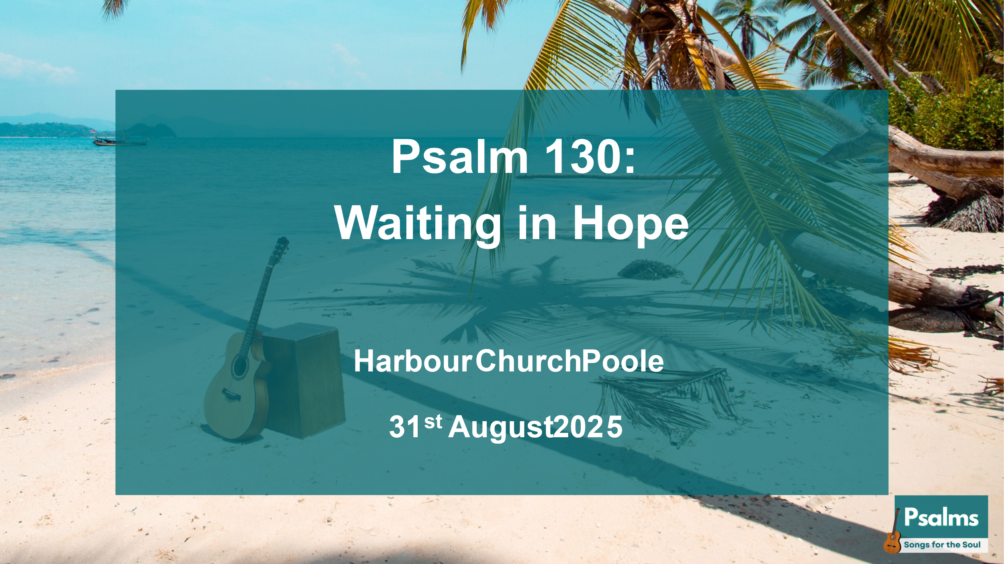
Psalm 130 – Waiting in Hope
(Harbour Church Poole, 31st Aug 2025)

Good morning! Today we’re continuing our series in Psalms, ‘Songs for the Soul’. And today’s Psalm is Psalm 130.
This is subtitled ‘A song of ascents’. And that refers to the ascent from the Judean countryside up to Jerusalem, which is built on a hill, and even more specifically to the ascent up the steps to the temple, which was built on the temple mount in Jerusalem. There are fifteen of these songs of ascents – Psalms 120-134 – and they were traditionally sung as a form of worship during the journey towards Jerusalem and the ascent into the Temple itself.
But they’re not all just happy-clappy worship psalms. And today’s Psalm 130 is a song of raw emotion. It’s a psalm of pain and distress, but also a psalm of hope in God.
Brigitte is going to come and read it for us. Brigitte is one of a group of us who have been memorising this Psalm over the last month. It’s been good to learn it together, and discuss it as we’ve been learning. If you’d like to join in the Harbour Church Scripture Memory group as we move on to learning a new passage together, please let me know afterwards, me or Chris Stuart.
Brigitte – are you going to read this morning, or recite from memory? And which version do you have? (I’ve got ESV on the slide here on the screen.)
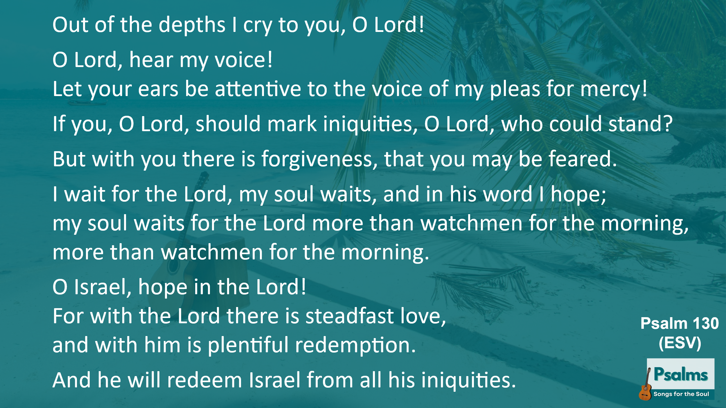
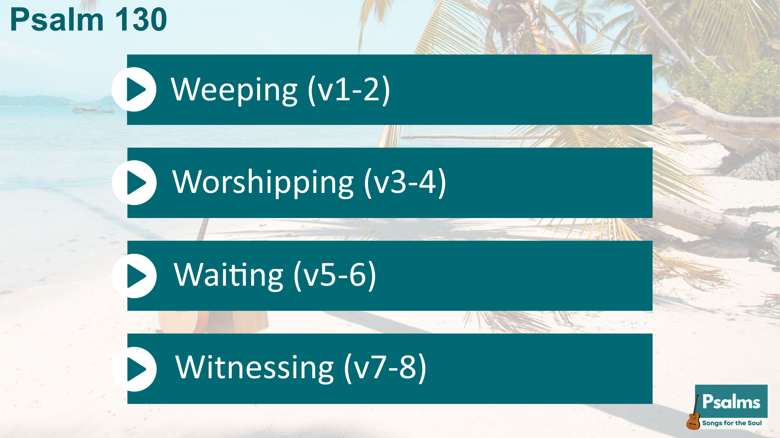
Now as we look at this Psalm this morning, it splits up quite nicely into four sections of two verses each, so here’s the structure we’ll use this morning:
- Weeping (v1-2)
- Worshipping (v3-4)
- Waiting (v5-6)
- Witnessing (v7-8)
(I have to credit Andrew Wilson for this set of four W-words. I’ve borrowed these titles from the book ‘The Life You Never Expected’ that Andrew and Rachel Wilson wrote together, using this structure.)

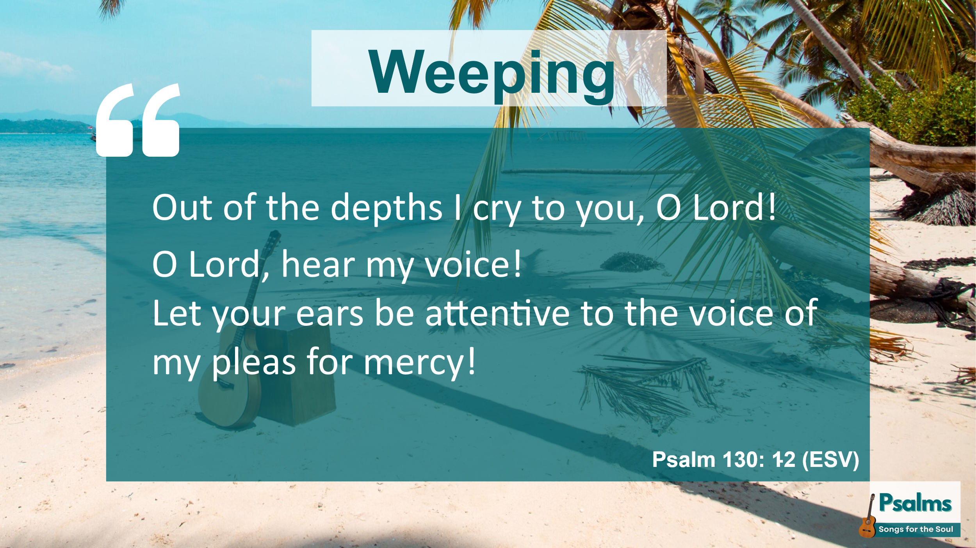
Weeping
So let’s start with verse 1. Out of the depths I cry to you, O Lord!
It’s not a happy opening, is it? This is someone in deep pain or suffering. Does anyone remember Anne of Green Gables? Poor Anne used to regularly say, “I’m in the depths of despair!” and it became a bit of a catch-phrase in our family when the children were younger.
Now the Psalm doesn’t actually say what is the specific problem was, which means it is easy to relate to a variety of situations. And maybe right now, some of you are feeling in the depths of despair – because of pain, or loss, or grief, or suffering, or any other difficulty. I’m in the depths, the psalmist is saying, I’m weeping. It’s an anguished cry from the heart. And he’s feeling sorry for himself, isn’t he?
But is he just drowning in his own tears? Is he just crying and weeping in despair? Yes, he is, but he’s not just crying to himself. Out of the depths, I cry to you, O Lord! He’s crying to God. He knows he’s in the depths, but he believes that God cares, and he’s crying out to God.
And look at the language here. He’s not just asking God; he’s crying out to God. He’s being insistent and demanding. Hear my voice! Be attentive to my cry! This is not a quiet, polite prayer, is it? It’s expectant and demanding. It’s like the way a toddler talks to their parent: ‘Look at this!’, ‘Help me now!’ Recognise that kind of attitude? A young child just assumes that Mum or Dad will stop what they’re doing and pay attention straight away. That’s how these first two verses sound to me.
When I read a psalm like this, I wonder if I’m usually too polite in my prayers, too restrained, too ‘British’! Do I really express the depths of my feelings to God? Do I cry aloud to him? Not very often. The opening of this psalm gives us a model of expressing ourselves to God – it’s ok to cry aloud, it’s ok to be insistent and demanding, it’s ok to express deep feelings. And it’s ok to wail. We don’t need to try to justify things, to explain things, to solve things. It’s ok simply to weep. Because just like a parent with a toddler, God cares! God cares about me. God cares about you. He’s always ready to listen to us, and he wants to hear the voice of our pleas.

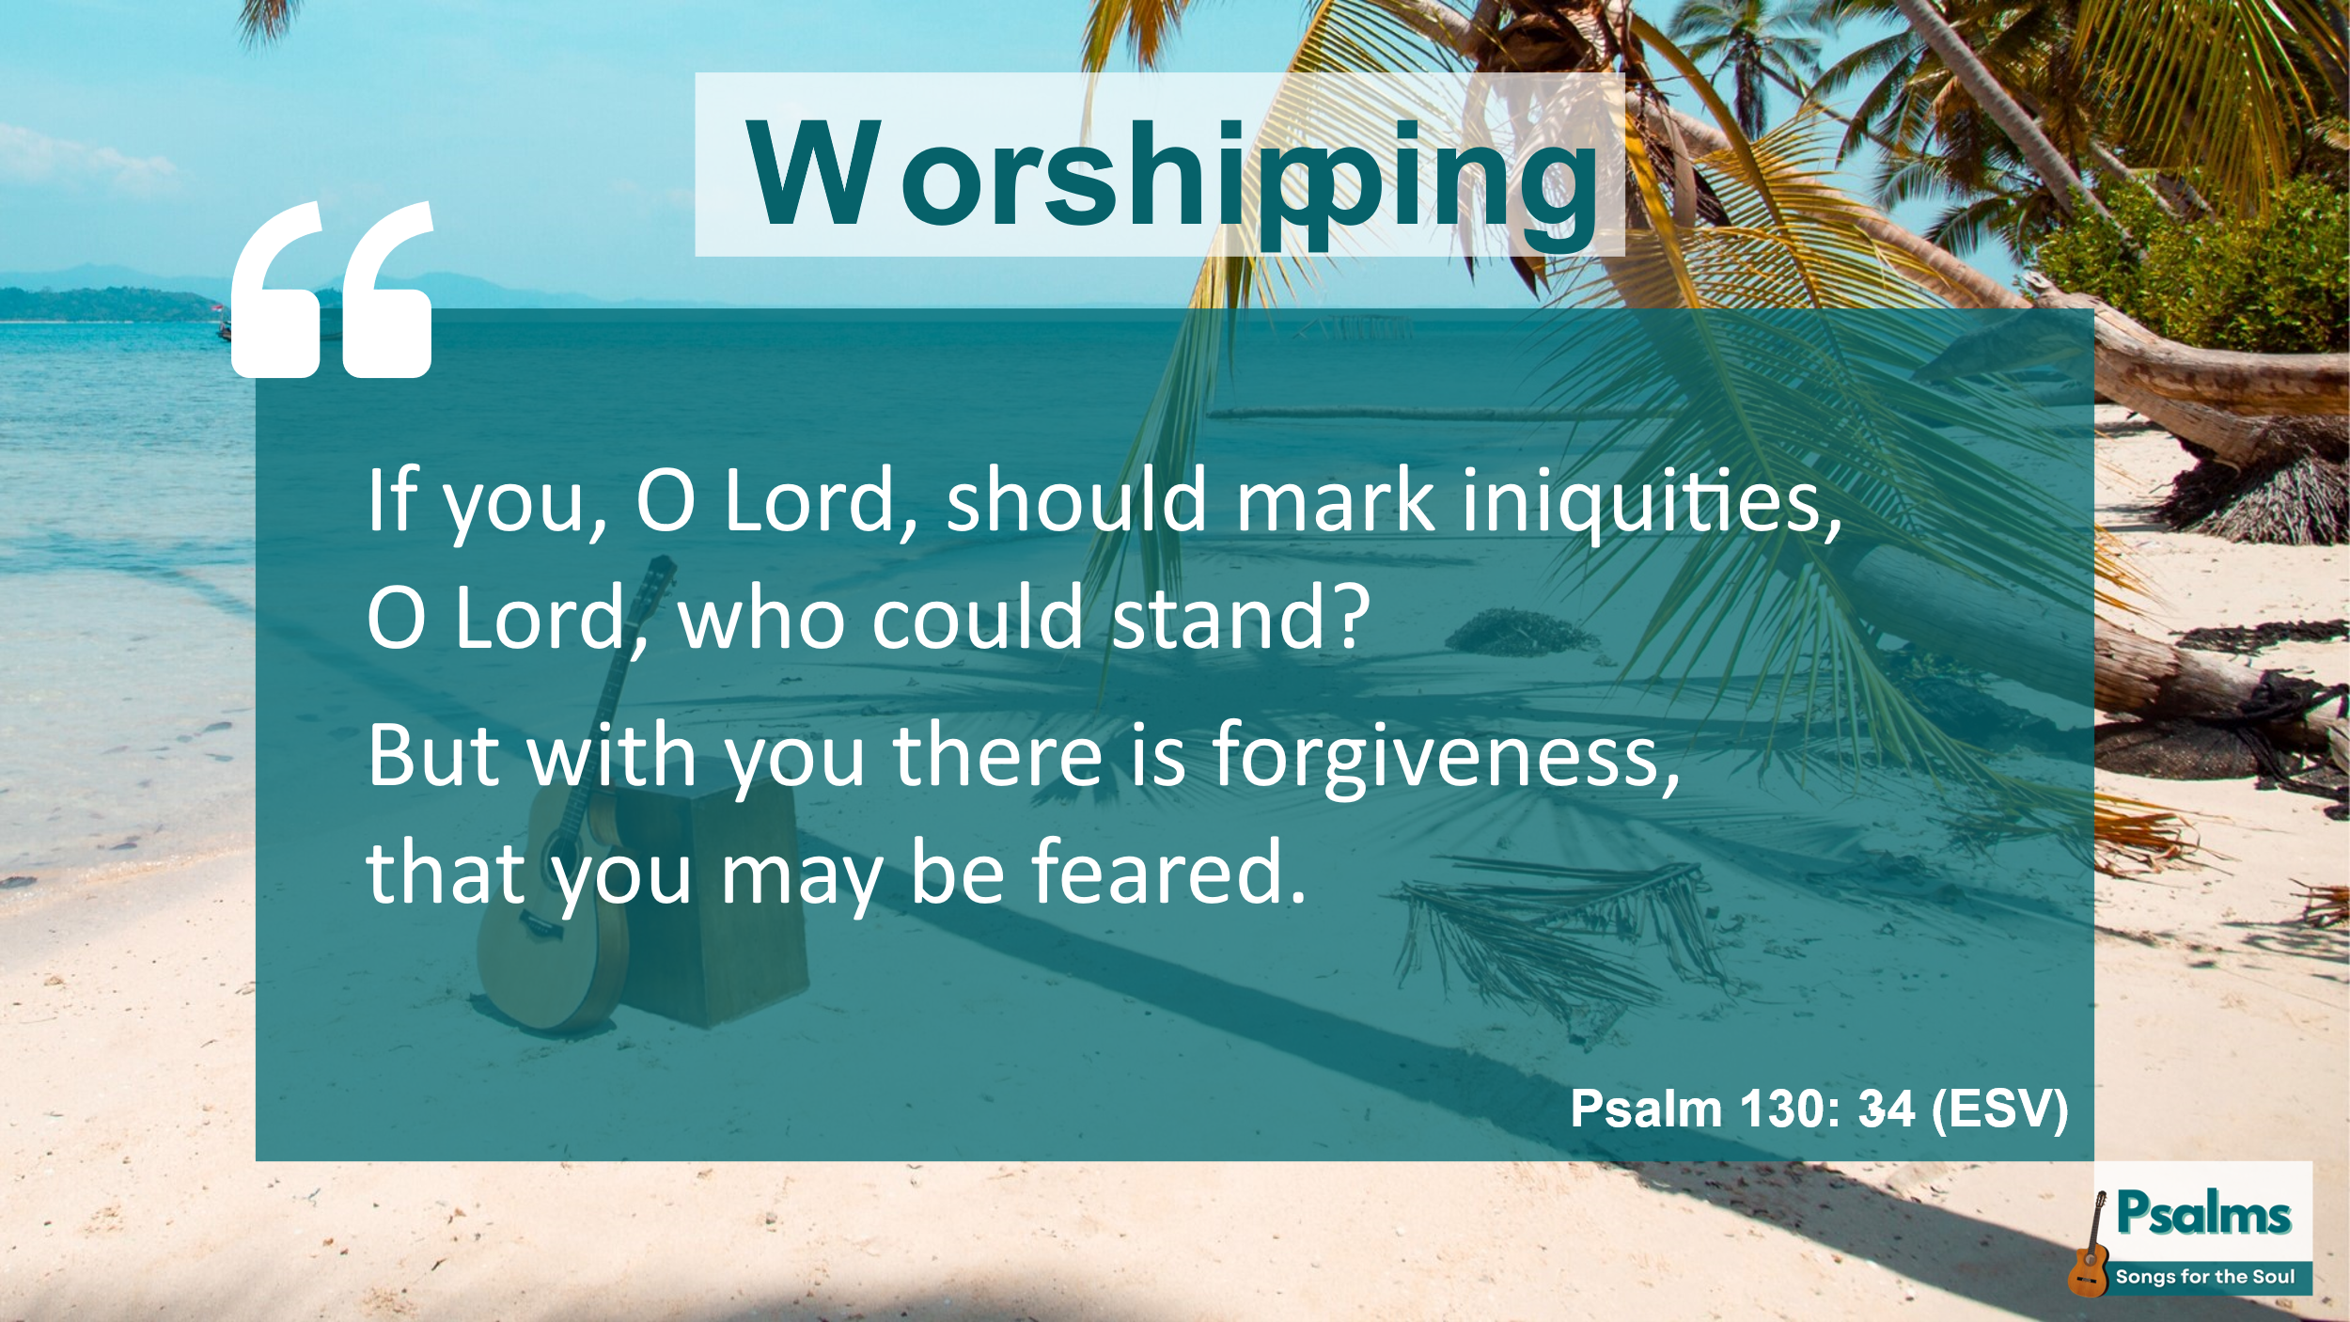
Worshipping
Now, having expressed his anguish and his deep feelings, in verses 3-4, the psalmist moves on from weeping to an attitude of worship toward God. If you, O Lord, should mark iniquities, O Lord, who could stand? He knows there’s iniquity in his heart, but he reminds himself that God’s grace and God’s forgiveness is far greater than his iniquities, so he can come to God in an attitude of worship.
Now to reflect on the word iniquity – it’s sort-of biblical jargon word, isn’t it? It’s not a word that anyone much uses in normal everyday speech. And in fact, some modern bibles don’t use the word iniquity – for example the NIV translation of this psalm uses the word ‘sin’ instead. But sin is a much more generic word, whereas the Hebrew word here is more specific. The way I find it helpful to remember is that iniquity is a description of inner sin. (Do you hear the similarity? Iniquity; inner sin.) Iniquity is about wrong thinking, wrong choices. The literal Hebrew word refers to crooked, or distorted thinking. This is distinct from a sinful deed, or a sinful action, which is a trespass or a transgression. Iniquity starts as a thought in the mind, so people around you can’t see it; other people don’t know about my iniquities.
But God sees all our secret thoughts, doesn’t he? So the psalmist, in the midst of grappling with his weeping, is aware of his wrong thoughts. So at the same time as he’s saying, ‘Lord, hear my voice’, he’s saying, ‘Lord, I know I couldn’t stand before you if you were to take count of all my iniquities.’ But God gives more grace, it says in James 4. God opposes the proud but gives grace to the humble. With God there is forgiveness, our psalm says, so I can approach him in my weeping, knowing that I’m forgiven.
And because of God’s grace, because of forgiveness, we can stand. The bible talks a lot about the burden of our iniquities – on our own we can’t stand because we’re weighed down by the enormity of our iniquities. But Jesus bore that burden, didn’t he? Isaiah says Jesus has borne our sufferings and was crushed for our iniquities. Peter says Jesus himself bore our sins in his body on the cross. God hasn’t just forgiven our iniquities, but Jesus himself bore our iniquities in his own body on the cross. So God hasn’t kept a record, he hasn’t marked our iniquities, and we really can stand in his presence, unburdened.
And then there’s this phrase, ‘that you may be feared.’ Why fear? Where does fear fit in here? We don’t talk so much about the fear of the Lord, do we? It doesn’t come in many of our worship songs. But the fear of the Lord is mentioned a lot throughout the Bible. We could make a long study of it, but I don’t have time for that this morning. But very simply, ‘fear’ here is like awe, respect, reverence. It’s an acknowledgement of our own littleness compared to God’s greatness, my weakness compared to his power and majesty.
And a healthy fear of God is the antidote to iniquity. Do you see the connection? What’s uppermost in your mind at any moment? Your iniquitous thoughts? Or the fear of the Lord? The more I fear God, in my mind, the less I want to entertain the iniquity, in my mind. The psalmist is coming to God, in the midst of his anguish, saying, ‘thank you for forgiving me my iniquity, help me to fear you more.’
And that’s the attitude of worship of a humble, sinful person in pain and suffering, coming before an awesome gracious God. And whatever situation we’re in, whether we are weeping or rejoicing, we can come to God with this attitude of worship – because we’re all of us totally dependent on his grace.

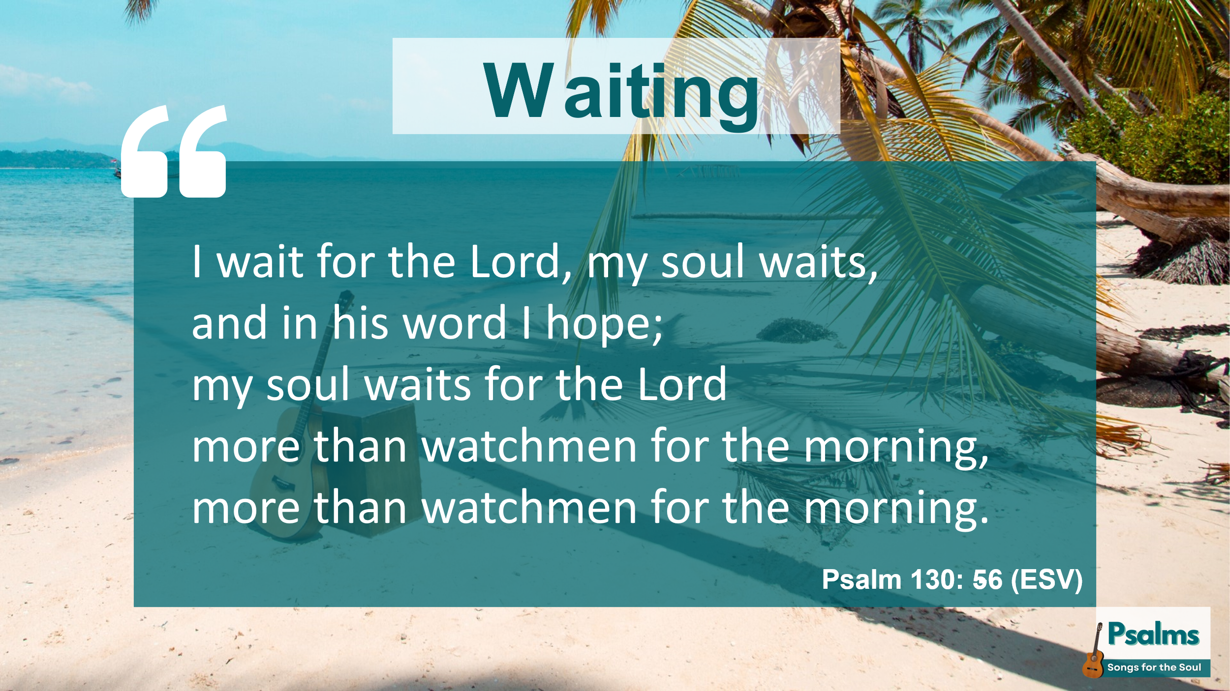
Waiting
And because we’re dependent on God, we can wait for him. We can wait in hope. We can wait in joy, and we can wait in weeping. “I wait for the Lord,” the psalm says, “my soul waits, and in his word I hope.”
His situation hasn’t changed, has it? He’s still crying to God from the depths. But despite this, he’s turned his attitude to worship, and now he’s reminding himself that he can wait for the Lord, in hope.
Because hope in God is not like human hope. Hope in God is not just an optimism that the situation will get better. It’s not like, ‘I hope it won’t rain tomorrow.’ Hope in God is a confident expectation and trust of the word of God, of our future with Jesus. John Piper puts it this way: “Christian hope is a confidence that something will come to pass because God has promised it will come to pass.” Christian hope is a confidence in God.
Now, the word ‘wait’ in English is quite a passive word, isn’t it? I’m waiting for my train to arrive. I’m waiting for a hospital appointment. Most of the time, in English, waiting means doing nothing, or just twiddling our thumbs, or doom-scrolling on the phone, until the thing we’re waiting for happens. But in this psalm the Hebrew word for ‘wait’ is qavah (קָוָה). This word implies much more than passive waiting; it signifies an active and eager expectation, a looking forward with hope, trust, and confidence.
So, the psalm says, we wait in hope. We wait expectantly. Our waiting is based on God – on who he is, on what he has done and what he will do. Christian hope is putting your trust in a trustworthy God. We can hope in God, we can wait for God, because we know he is trustworthy. We wait for the Lord. We’re not waiting for him to do something for us, to suit my own agenda. We wait for him, himself. We wait for his steadfast love, for his plentiful redemption. We wait, simply because he is God.
Here’s an analogy – think of a waiter in a restaurant. He or she waits for the customer, right? The waiter doesn’t have his own agenda, waiting for the customer to do something for him, does he? He waits for the customer, attentive, ready to serve, eager to do what the customer wants. It’s not by any means a perfect analogy, because God doesn’t just want us to wait for an order. Because actually, we don’t just wait on God like a servant, we wait for him in relationship, as sons and daughters.
In Romans 8, Paul says, “We wait eagerly for adoption as sons, the redemption of our bodies. ²⁴ For in this hope we were saved. Now hope that is seen is not hope. For who hopes for what he sees? ²⁵ But if we hope for what we do not see, we wait for it with patience.”
This language in Romans 8 is similar to Psalm 130. We wait eagerly for our redemption, Paul says. With the Lord is steadfast love, our psalm says, and plentiful redemption.
And then, the psalm says, we wait for the Lord more than watchmen for the morning.
In our Harbour Scripture Memory group, Diana shared a great illustration of this, and I’ve asked her to share it this morning . . .
[Diana] “When I was in the hospital, out of intensive care, in a single room, each morning a seagull used to come and perch on the roof of a building which I could see. I lay there longing for it to appear because I knew that soon it would be morning. And reading this psalm, I know that I don’t watch for the Lord’s return with the same longing, nor with that desperate eagerness for the Lord to make his presence a reality to us all when we gather for worship on Sundays.”
Isn’t that a great encouragement? Thanks, Diana. What if we all had that longing, that eagerness to really know the presence of the Lord?
The watchman waits for the morning, he trusts that morning will come. He doesn’t really think, does he, when it’s pitch dark at 3 am, ‘Wow this is a long night, maybe the sun won’t come up tomorrow. Maybe there won’t be a morning.’ No, however dark it seems, he trusts that morning will come. He waits and he hopes.
So, when you’re in a difficult place, maybe even this morning, often you can’t see much likelihood that the circumstances will get any better any time soon. But we can still choose to wait in God. We can still choose hope. Hope based on God’s character, based on who God is and his steadfast love for us. Not just waiting for the situation to change, although of course God can intervene supernaturally in any situation, but we can also choose to wait for the Lord despite the situation.

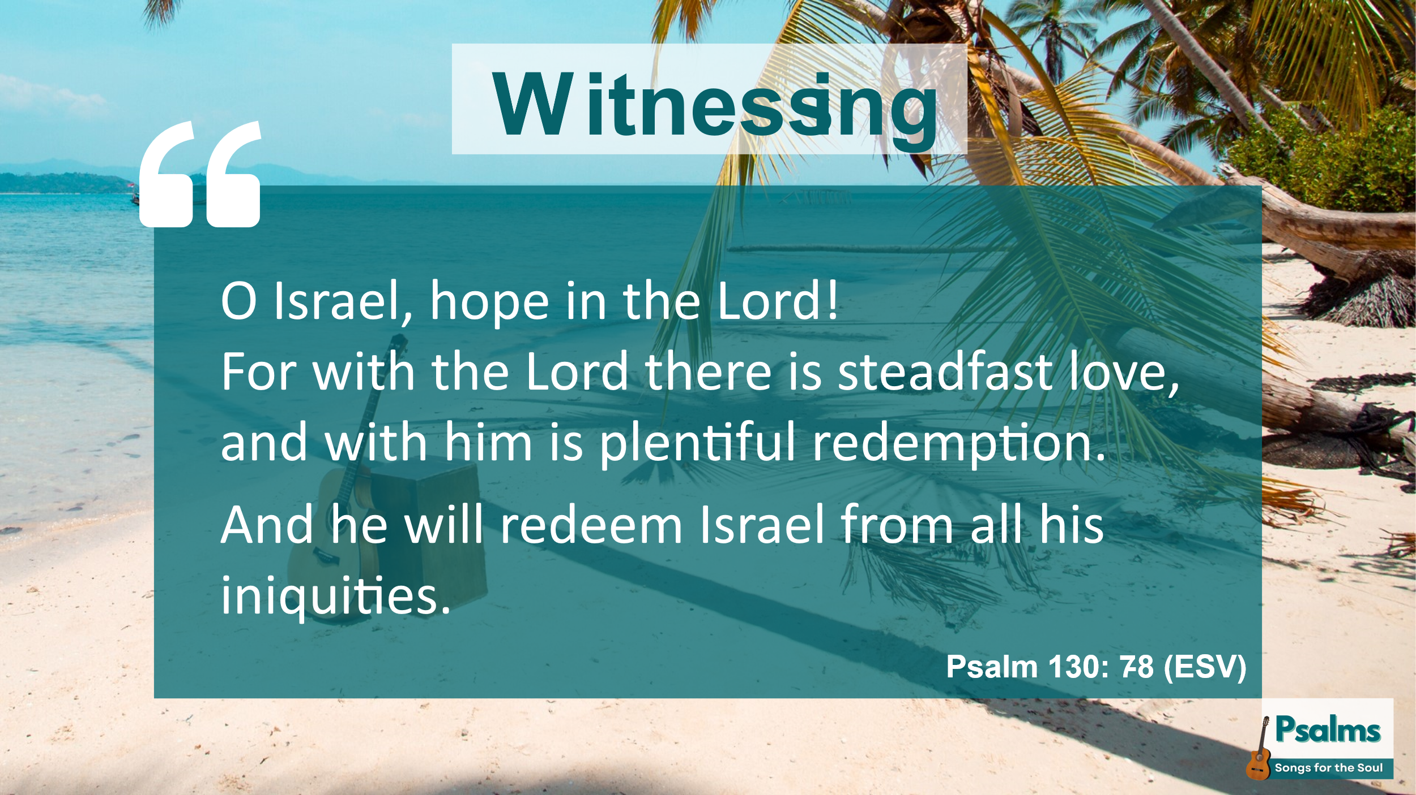
Witnessing
So, let’s look at the last two verses of the psalm, because here the perspective changes. The first six verses have been focussed on me, on I. ‘I cry to you’, ‘Hear my voice’, ‘I wait for the Lord’. The psalmist has been expressing his own feelings, and reflecting on his own relationship to God.
But now he starts, ‘O Israel …’ He’s addressing the community. He’s turned to witnessing about God to the people around him. You, he says to everyone, you can put your hope in the Lord. He’s not just addressing his own need, he’s witnessing to an eternal truth: with the Lord is steadfast love, for you, for everyone.
And with the Lord is redemption - plentiful redemption, or even plenteous redemption, as it says in the King James version. Don’t you just love that word, plenteous? This is an eternal truth. We all fall short of the glory of God, it says in Romans. We all deserve punishment for our sins, for our iniquities, don’t we? But God does not mark our iniquities. With God there is plenteous redemption. He sent Jesus into the world to share our human experience. Jesus lived a life without iniquity. Yet he was condemned to death on the cross. He bore our iniquities, so that we could be redeemed. With God there is plenteous redemption – for all of us. He will redeem Israel, and everyone of us, from all our iniquities.
And that’s the good news of the gospel. And the psalmist knows that it remains good news, even when he’s crying to God from the depths. And in the same way, we too can bear witness to the good news of the gospel message, even while we’re weeping and waiting. We can express our pain and our suffering, but we can also witness to the knowledge of God’s love that sustains us, and the eternal life that we know that he offers us.
We can bear witness to others to the love of God, not just when we’re feeling happy, but also when we’re suffering. In fact, our witness from a place of hurt or pain can often be even more powerful, because we can come alongside another person with empathy. We can share their pain, and we can share the truth of God’s steadfast love, and we can wait on him together. Isn’t that more meaningful to most people? Isn’t that why we can relate to this psalm so well?

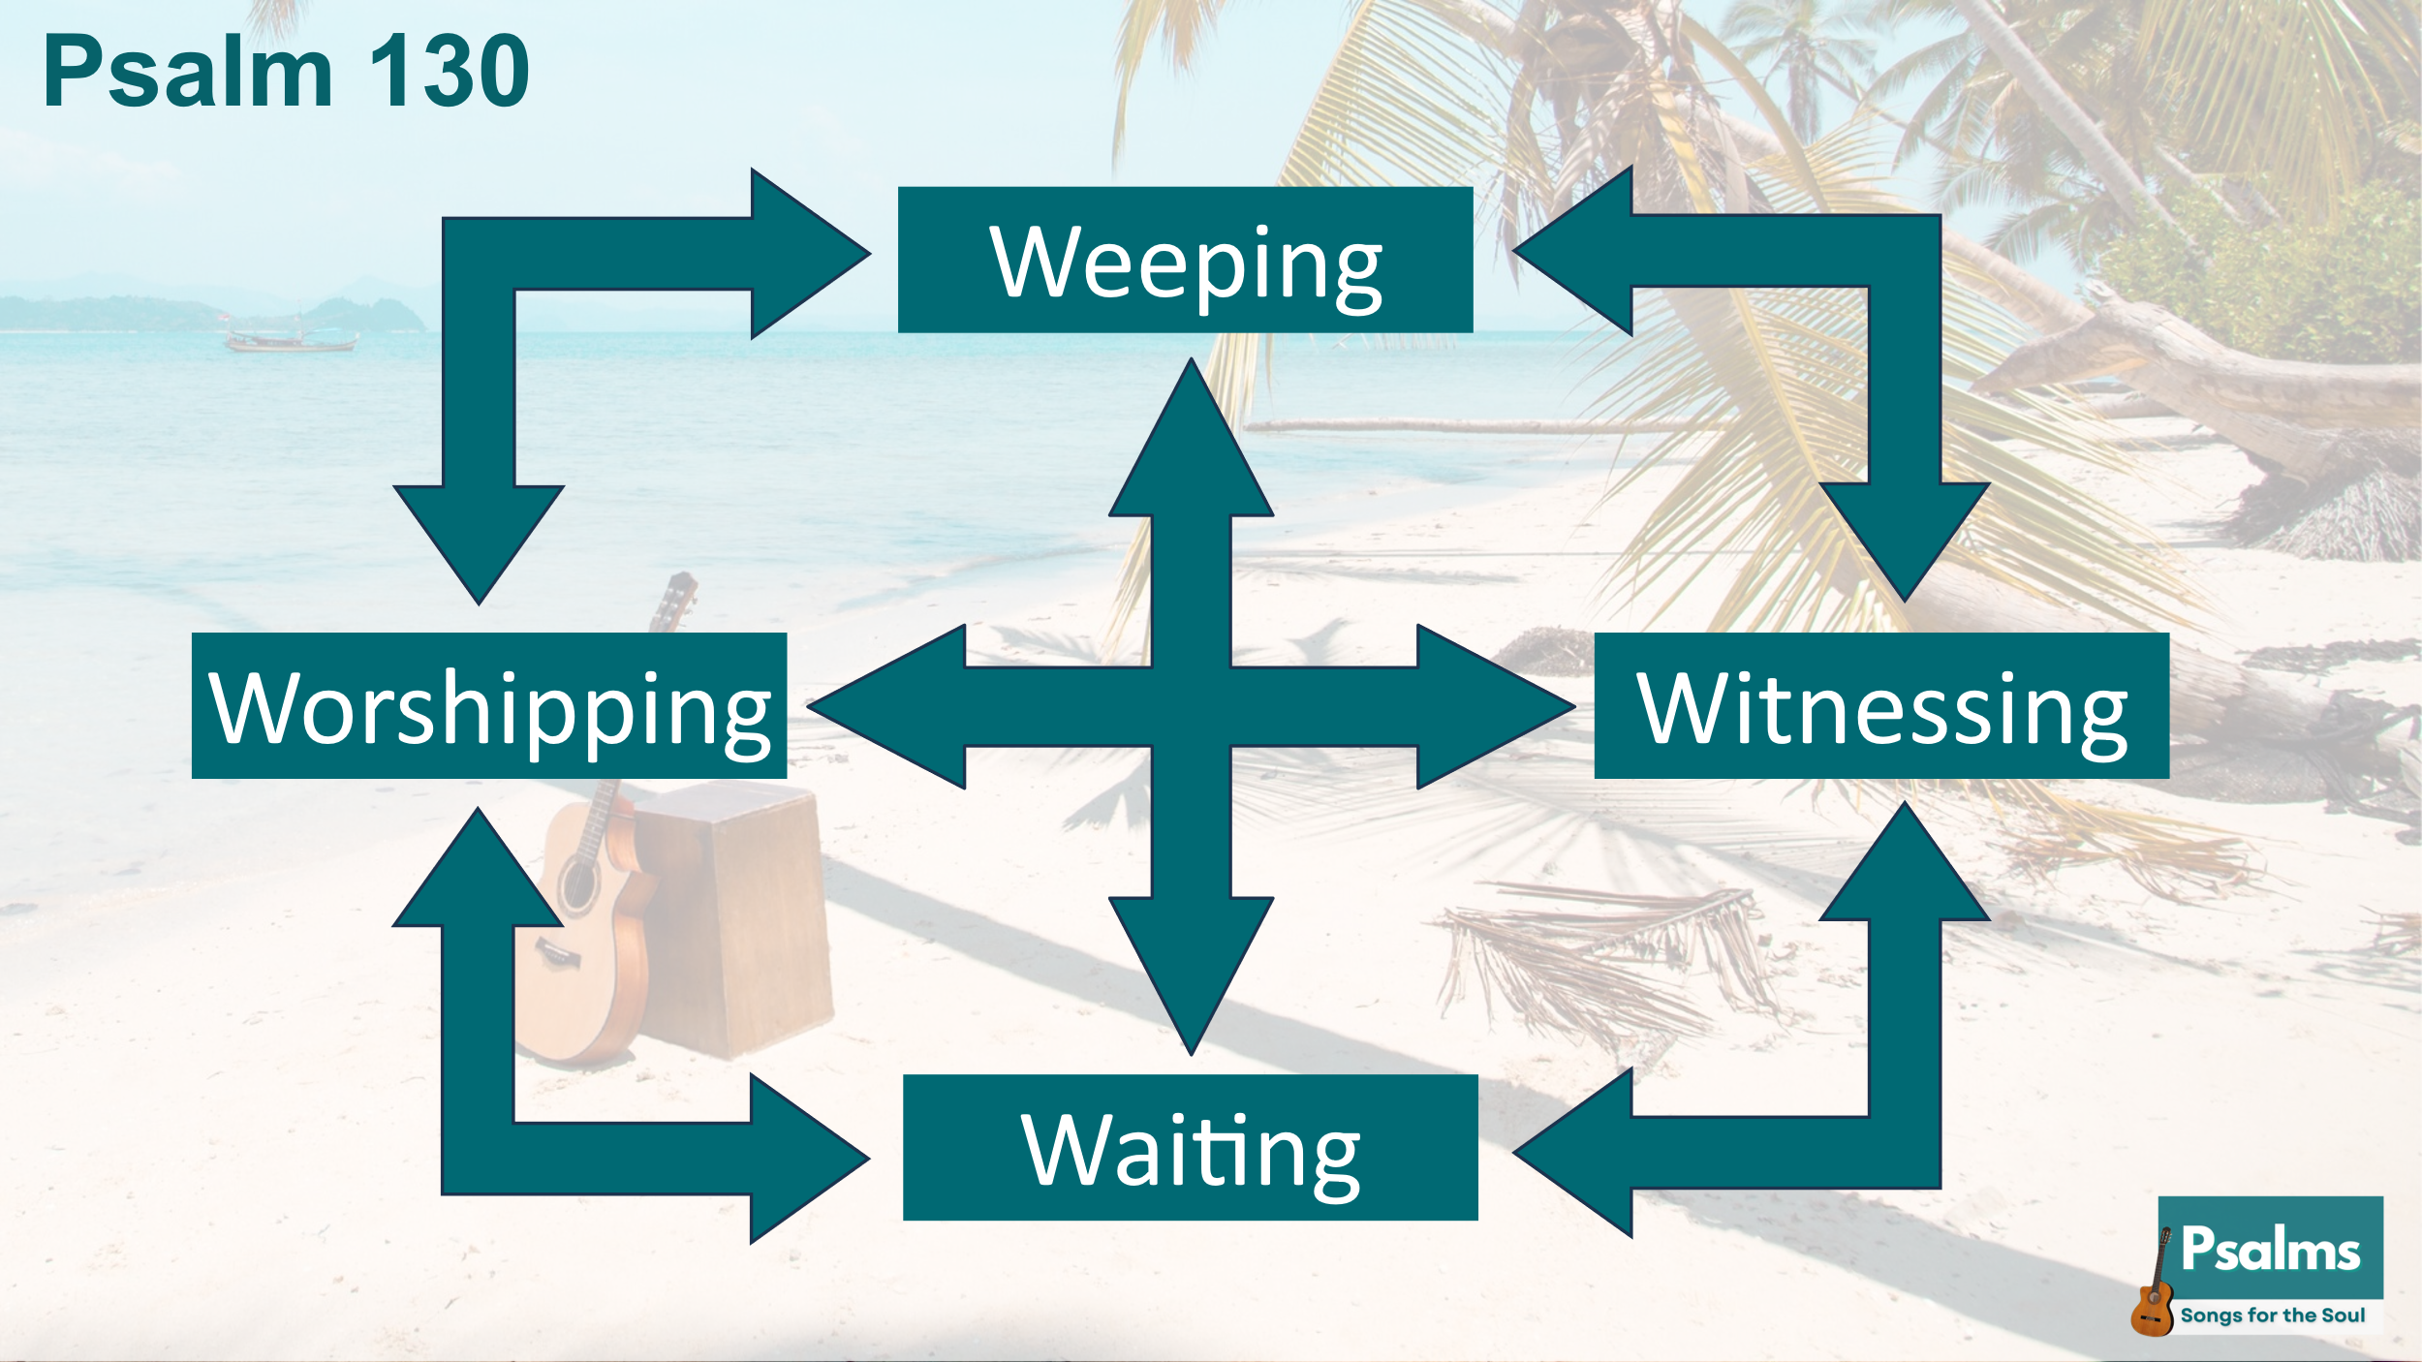
Conclusion
Because in reality, this is not a sequential process of weeping, worshipping, waiting, witnessing. It’s a continual cycle. There’s nothing to say in this psalm, that the circumstances have changed for the person who wrote it. At the end of the psalm, he’s still facing, isn’t he, whatever the problem was that caused him to be weeping in the first place. He’s still waiting for the Lord, still hoping. But he can choose to worship too, and he can choose to witness to God’s steadfast love.
In fact, most of us can relate to all of these most of the time, can’t we? I expect everyone in this room has something in their lives that they’re weeping about, and something that they’re waiting for. And at the same time we can all turn to God in worship, and turn to people around us in witness. Don’t fall into the trap of thinking you can’t worship or witness while you’re waiting, or even while you’re weeping.
Of course, at any given moment, one of these might feel for you more dominant than the others. But it’s about 3000 years since this psalm was written, and through all that time the people of God have wept, and worshipped, and waited and borne witness, knowing that the steadfast love of God never ceases.
So if you’re mainly weeping today, then go ahead and weep and cry out your feelings to God. And if you’re mainly waiting, then keep on waiting, trusting, hoping, because God is faithful. And if you’d like someone to pray with, to share your pain, our prayer team will be here on the right after this, available to pray with you.
And if you’re mainly worshipping today, go ahead and worship with enthusiasm. And if you have the opportunity to witness to others, go ahead with boldness.
And wherever we all are in this confusing mixture, let’s bear with each other. It’s always OK that some are sad and some are rejoicing, that some are weeping and some are worshipping. We can support one another, we can encourage one another, and we can love one another. Today I might need your support. Tomorrow I might be able to support you. Or the other way around.
So whether you’re weeping today, or worshipping, or waiting, or witnessing, let’s make every effort to love one another as Jesus has loved us. For with him there is steadfast love and plenteous redemption. Thanks be to God!

