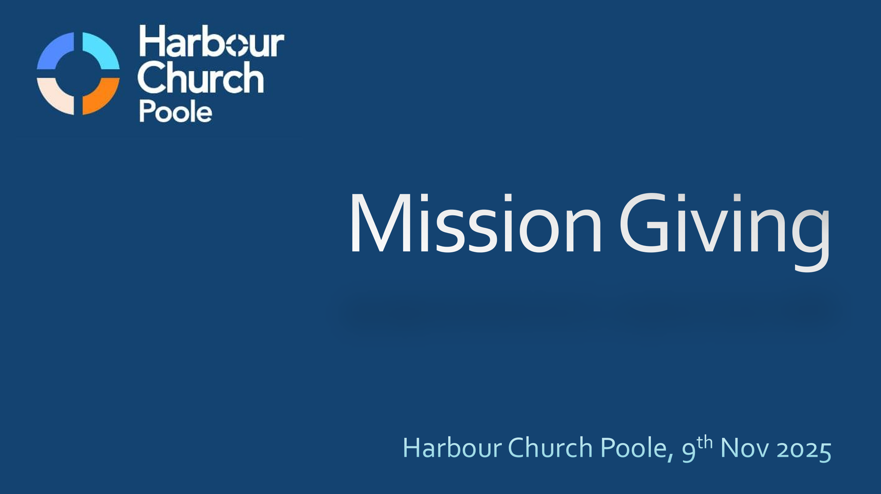
Mission Giving
(Harbour Church Poole, 9th Nov 2025)

Good morning! Today we’re talking about giving to World Mission. My talk this morning will cover two points:
- Why do we give to mission partners in other parts of the world? What’s the biblical basis for giving?
- Who is Harbour Church supporting? And how can each one of us be involved?
And it’s not just me doing all the talking this morning. I’m going to invite several other people to share about some of the specific things we’re supporting as a church.
But to start with, let’s look at the principles of giving that are laid out in the Bible. Why do we give money, or time, or resources to support the church or to support other mission projects? How much should we give? How should we decide who to give to?
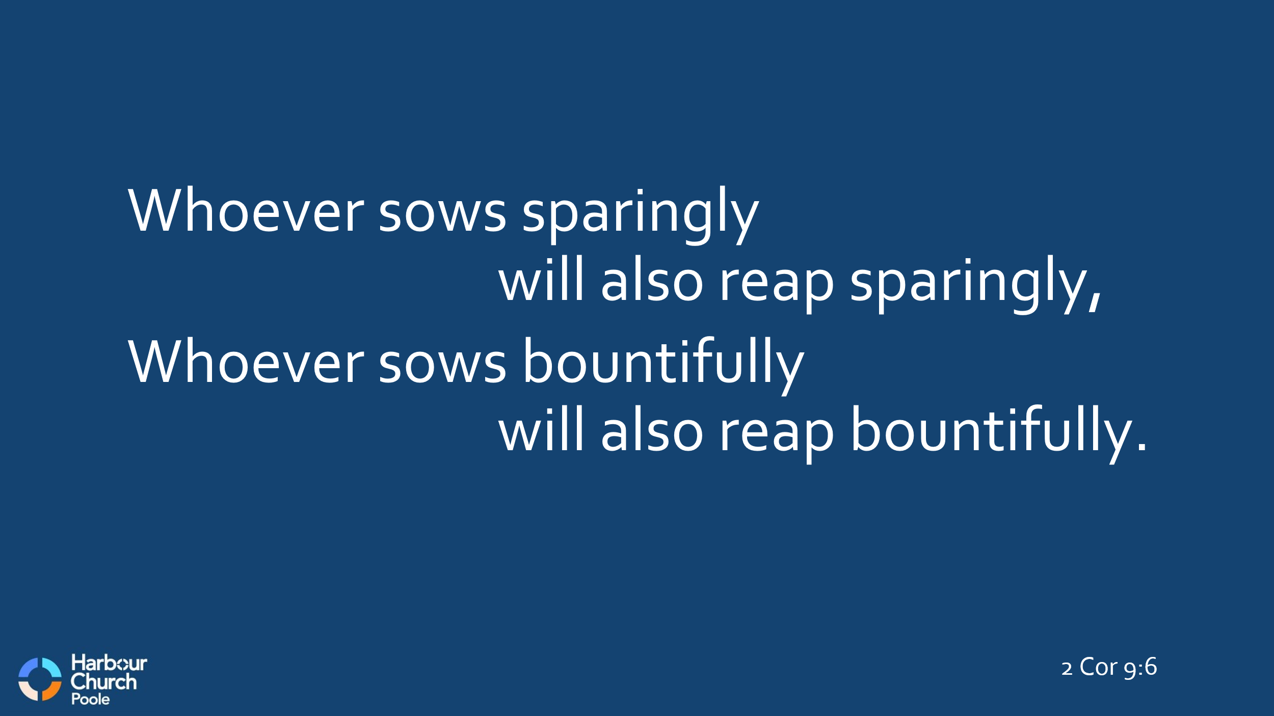
Good questions, huh? You won’t be surprised to hear that I’m not going to give you specific answers on a plate this morning. Throughout the Bible, God encourages an attitude of generosity. But exactly how generous you should be, and to whom – well that’s between you and God. But there is a general principle – the more generous you are, the more God will bless you. We’re going to look at 2 Corinthians this morning, but as a first taste, look at 2 Cor 9:6. Paul sums up God’s perspective on giving very simply:
“The point is this,” he says, “whoever sows sparingly will also reap sparingly, and whoever sows bountifully will also reap bountifully.” If you’re generous, you’ll experience the blessing of that generosity.
Now right up front, I want to make it clear, I’m not preaching a prosperity gospel here. God wants us to be generous, sure, and God certainly wants to be generous in blessing us, but there is no promise of financial wealth. God’s blessing in our lives comes in many forms. The principle of sowing and reaping is clear, but anyone who gives because they expect a financial reward is missing the point. Andy spoke about idols last week, didn’t he? We always need to be wary of letting health, wealth or prosperity become an idol in our lives that gets in the way of our relationship with God.
And we’ll go back to that passage in Corinthians in a while, but before we talk specifically about world mission, it would be good to start with a recap about tithing and giving. Because right from the beginning, God established a principle of tithing 10% of your income, and then freewill giving in addition to the tithe.

So, what is a tithe? Quite literally, it comes from the Hebrew word meaning ‘a tenth’. Multiple times in Leviticus, in Numbers, in Deuteronomy, God commanded his people to set aside the first tenth of all their produce, and to present that as the Lord’s offering. And the primary use of that tithe was to support the priests and the Levites.
If you think about it, it makes sense mathematically. There were twelve tribes of Israel; eleven of them were allocated land to farm and grow crops and rear animals and so on. And the Levites were not allocated any land, because their duty was to serve the Lord in the tabernacle, or later, in the temple. So the Levites had no animals, no fields, and so they had no food. But if all the other Israelites gave a tithe of their produce, then the Levites would get a generous amount to live on and feed their families, even though they weren’t producing anything themselves. So that’s the principle of the tithe. The Levites received eleven-tenths, which is a generous allowance.
And the same holds true for the church today. If everybody in a given church gives a tithe of their income, then a church of ten households could support a minister to the level of the average income of the church members. Do you see? The principle of tithing is to provide for the ministers who support the work – whether Levites in the Old Testament, or church pastors and staff members today. We’re blessed, aren’t we, with staff who work for Harbour Church and serve us all – Andy, Tim, Helen, Becci, Izzie. And the church can pay them their salary, because the members of the church, you and I, give tithes to the church.
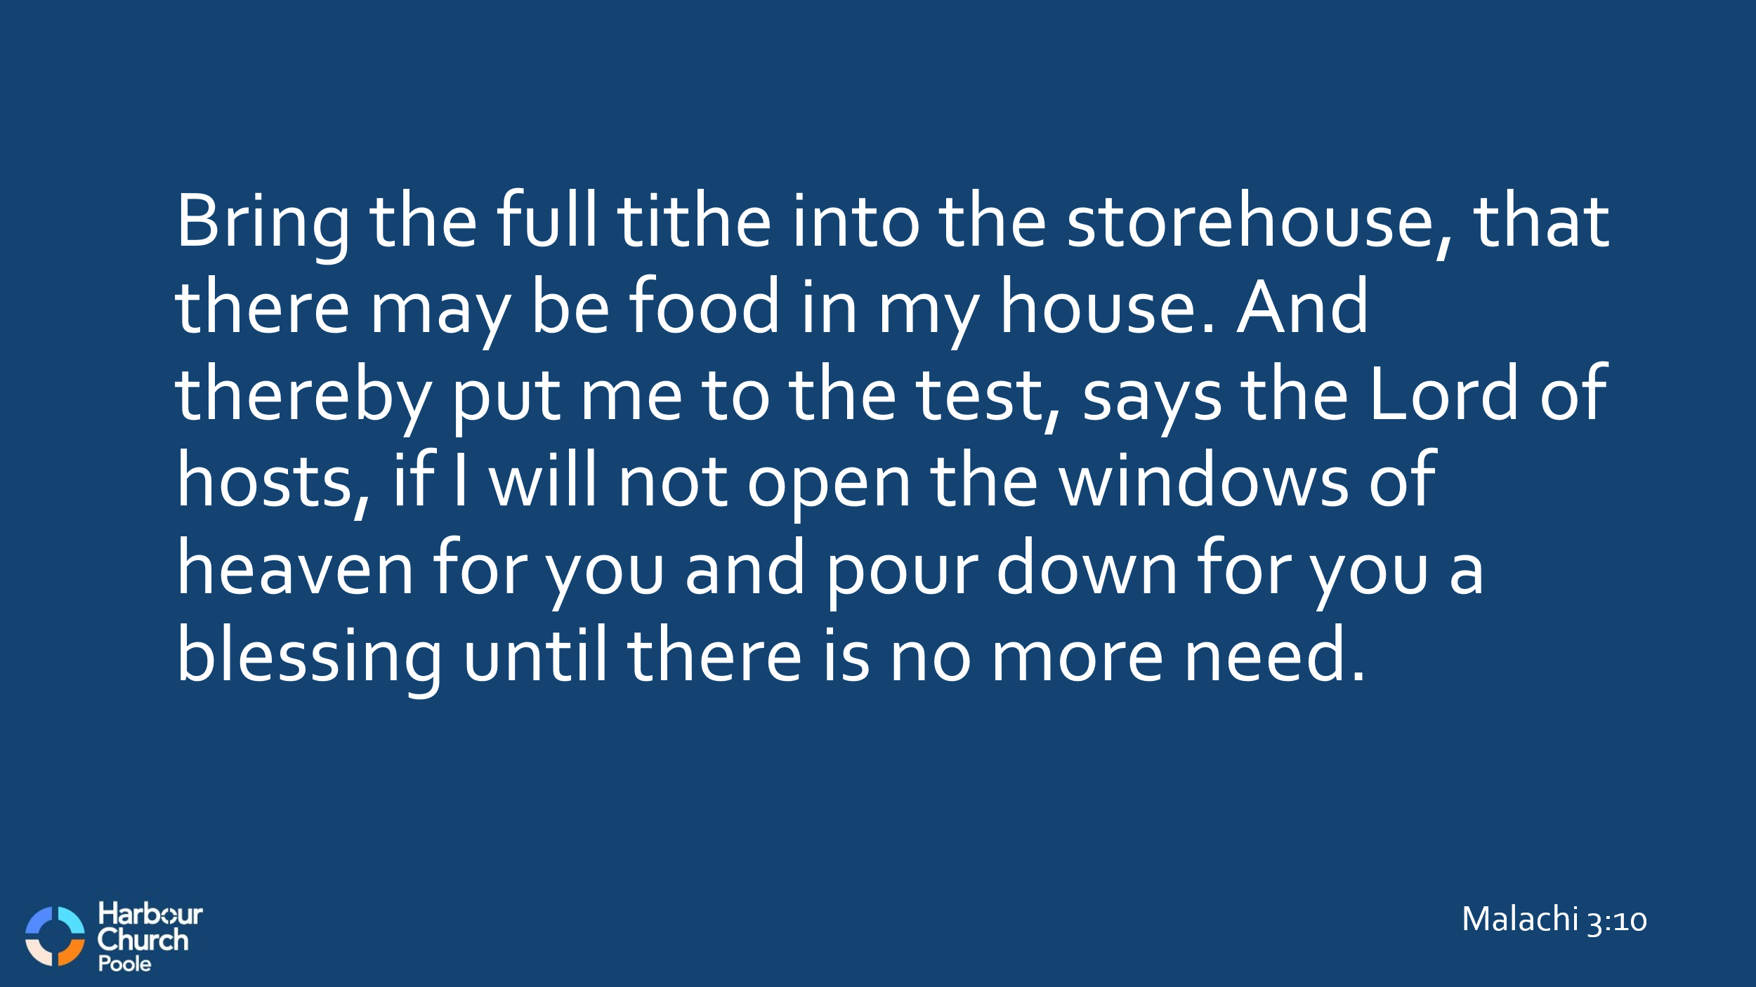
So that’s the first principle for this morning. Be generous, not stingy, with your tithe. Because all through history, people have tended to give less than 10%, so that they can keep more for themselves. Do you ever feel like that? Do you ever say, I can’t afford to give 10% of my income to the church, because I’d miss out on my . . . you fill in the blank! I know I used to feel like that, and I expect most of us have, right? But there’s a strong warning in Malachi about such an attitude. God says, in Malachi 3, that the Israelites at that time were robbing him. That’s quite a harsh assessment, isn’t it? Robbing God! Look at Malachi 3 v8: “You are robbing me,” says God, “But you say, how have we robbed you?” And God says, “In your tithes and contributions. You are cursed with a curse because you are robbing me, the whole nation of you.”
This is strong language indeed! But then God goes on, in v10, “Bring the full tithe into the storehouse, that there may be food in my house. And thereby put me to the test, says the Lord of hosts, if I will not open the windows of heaven for you and pour down for you a blessing until there is no more need.”
A blessing until there is no more need. . . So my first encouragement to you this morning, is to bring the full tithe. And don’t get me wrong, it’s not my place to be heavy-handed. I’m not here to coerce you, and no one is going to check up on you. But God says, put me to the test. So let me encourage you this morning - choose to give a full tithe of your income to the church, and see how God will open the windows of heaven for you and pour down a blessing.

And now, with that basic principle of tithing in place, let’s move on to talk about giving to others beyond this local church. We have decided, as Harbour Church, that we will adopt the same tithing principle. We will give 10% of the church’s income to support other mission partners, both in the UK and around the world. And today we’re going to introduce to you the three global partners that we will be supporting regularly. We don’t have time this morning to cover our UK partners too, but if you come to the members’ meeting next Sunday, we’ll give you a run down of those.

But this morning’s focus is on our global mission partners. So, first off, Jane is going to introduce Child of Hope in Uganda . . .
[Jane – intro to Moses and Bex, plus video]
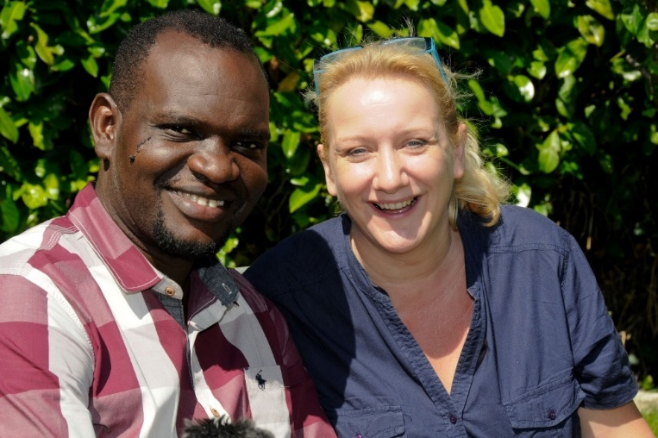
So to confirm, Harbour Church has decided to increase the monthly support to Child of Hope, compared to what PCF was giving previously. And we’ve also given them a one-off gift from the fund that’s built up over the last year, enough to repair one of their vans, which was off-the-road, and also to purchase a walking tractor, something like this:

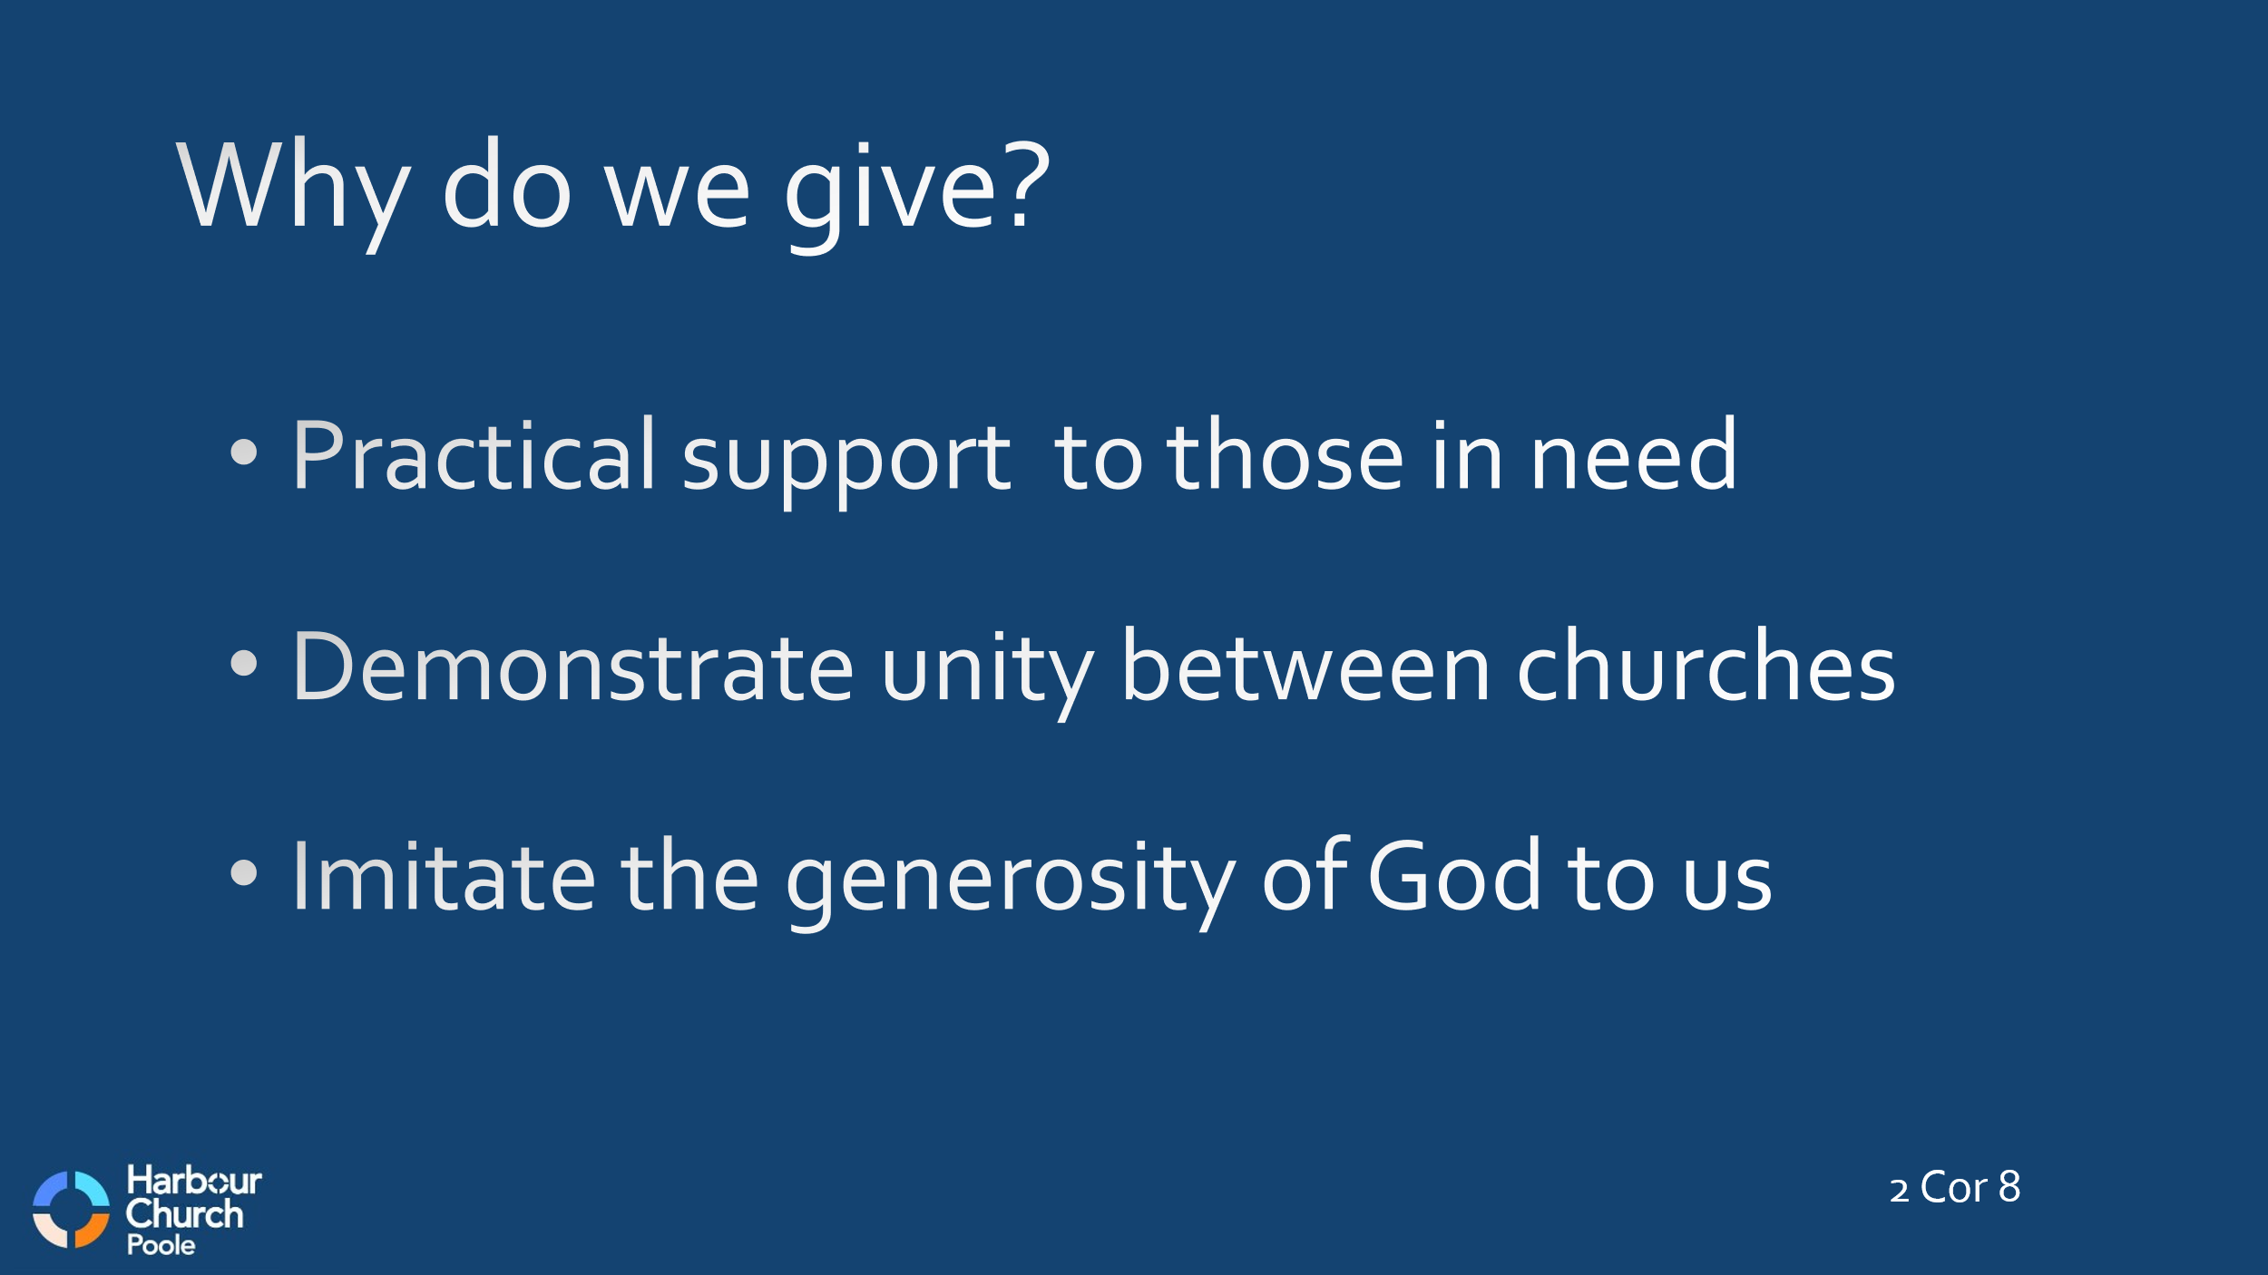
Now, as promised, let’s look at 2 Corinthians and see what Paul says there about giving to support mission. We’re looking at chapters 8 and 9. The context is that Paul is encouraging the churches in Asia Minor to take up a collection to support the Christians in Jerusalem, who at that time were suffering because of famine and persecution. He refers to this collection several times in various letters, and he later delivered the money in person. Paul gives the Corinthians several reasons for this gift:
- It was practical support for those in need in Jerusalem
- It was a demonstration of unity between the Gentile and the Jewish churches
- It was an opportunity to imitate the generosity of God to us
And all these apply to us too today, don’t they? We can give to those who have less than we have. We can demonstrate unity between churches in different countries. We can be generous, just as God has been generous to us.
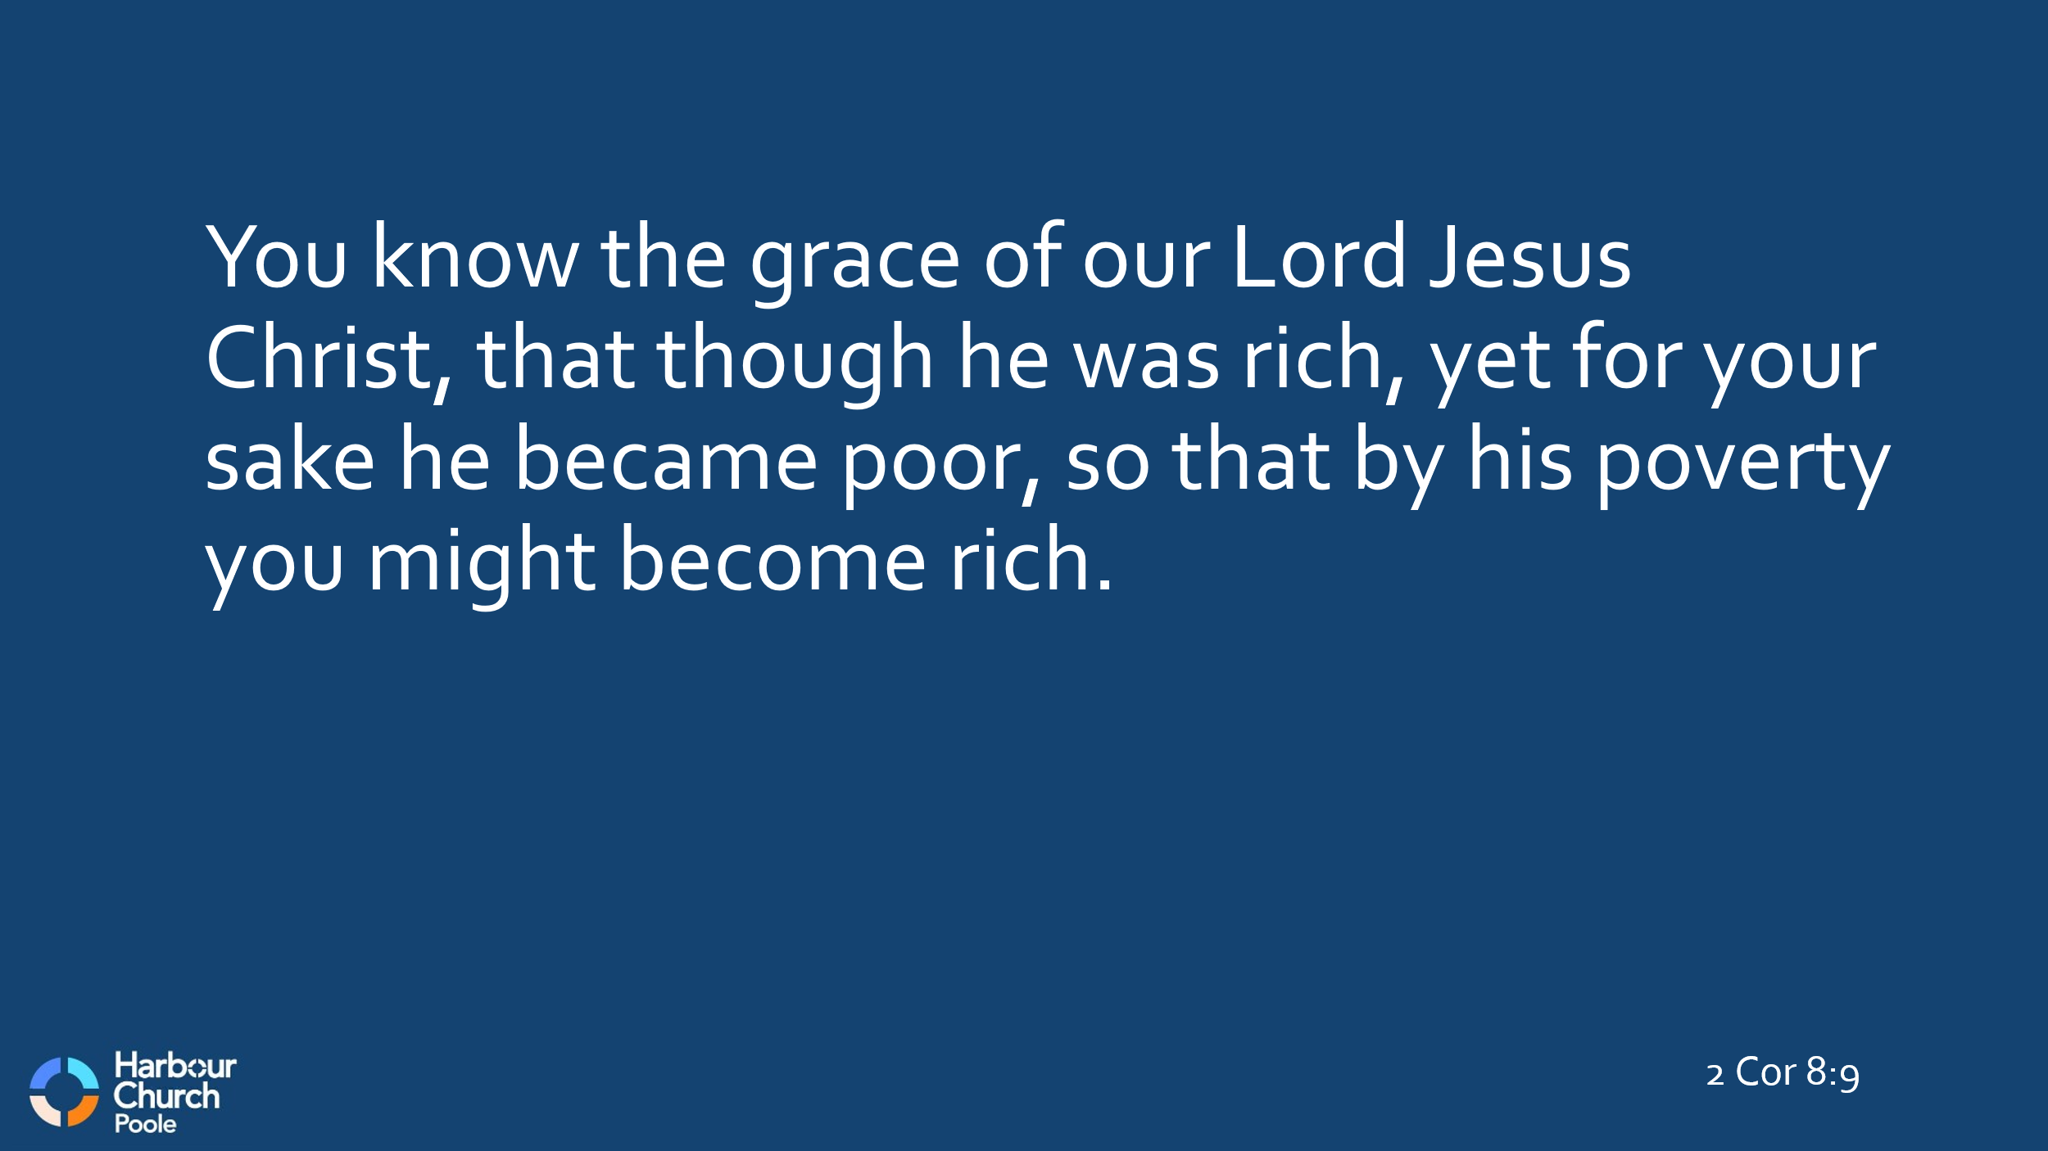
In 2 Cor 8:9, Paul says, “You know the grace of our Lord Jesus Christ, that though he was rich, yet for your sake he became poor, so that by his poverty you might become rich.” This is the model of generosity, isn’t it? Jesus gave up everything, he humbled himself to the point of death, so that we might be made rich in our relationship with him through the abundant grace of God.
So that, in a nutshell, is why we should give to support others.

And with that, let’s hear from Andy about another of the partners that Harbour Church will be supporting . . .
[Andy – Fred & Jo, Sahrawi people]
It’s great isn’t it to have the opportunity to support a Christian witness among a people group that so far has not one Christian church. We can give financially, and we can support them in prayer.
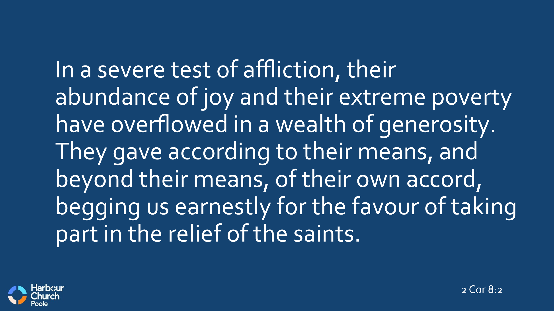
Now, back to 2 Corinthians. Paul is writing to the Corinthians from Macedonia, and in chapter 8 he honours the Macedonians for their generosity, even though they themselves are not at all wealthy. Look at chapter 8, v2: “In a severe test of affliction, their abundance of joy and their extreme poverty have overflowed in a wealth of generosity. They gave according to their means, and beyond their means, of their own accord, begging us earnestly for the favour of taking part in the relief of the saints.”
Do you get that? The Macedonians were in extreme poverty, Paul says, and a test of affliction. But they also had an abundance of joy and a wealth of generosity. They gave even beyond their means, begging earnestly to take part in giving. Wow! What an example! How often do we feel like that?
And in this letter, Paul is deliberately challenging the Corinthians. It’s clear that the people of Corinth were actually much richer than the people of Macedonia. And yet the people of Macedonia were more generous! So Paul says to the Corinthians, in v14, “as a matter of fairness, your abundance at the present time should supply their need, so that their abundance may supply your need.”
He's challenging the Corinthians – you have abundance in finance at the moment; you can supply the needs of others. But you have non-financial needs that they can supply to you – in grace, in faith, in prayer, perhaps.
And then in chapter 9 Paul continues with the point that I read out at the beginning. I didn’t have time this morning to read out the whole two chapters, but I’m going to read this section in full. You’re welcome to read along with me – 2 Corinthians 9 from v6 to v11:
The point is this: whoever sows sparingly will also reap sparingly, and whoever sows bountifully will also reap bountifully. Each one must give as he has decided in his heart, not reluctantly or under compulsion, for God loves a cheerful giver. And God is able to make all grace abound to you, so that having all sufficiency in all things at all times, you may abound in every good work. As it is written,
“He has distributed freely, he has given to the poor;
his righteousness endures forever.”
He who supplies seed to the sower and bread for food will supply and multiply your seed for sowing and increase the harvest of your righteousness. You will be enriched in every way to be generous in every way, which through us will produce thanksgiving to God.

The point is this, Paul says: If we give sparingly, we will reap sparingly. If we give bountifully, we will reap bountifully. The Corinthians were thinking of giving sparingly, even though they were rich. The Macedonians were already giving bountifully, even though they had little.
But even as he says this, Paul is clear, we shouldn’t give because we feel obliged to, or because someone like me stands here and reads this chapter and you feel reluctant or guilty. No, please don’t hear me that way! God wants each of us to decide in our own heart how to give, he wants us to listen to his leading, and then, to give cheerfully.
Because the fundamental principle is here in the next verse – however bountifully you give, you can’t out-give God, because God is able to make all grace abound to you. Do you get that? All grace! That’s unimaginable, isn’t it? God wants to give us all sufficiency in all things at all times. That’s a lot of ‘all’s isn’t it? All grace, for all sufficiency in all things at all times. Wouldn’t that be a good place to be?
And why does God want to give us all this? It’s in the end of that same verse, ‘so that we may abound in every good work.’ God wants to give bountifully to us, so that we can give bountifully to others. God makes all grace abound to us so that we can abound in every good work. Isn’t that good news? Isn’t that a great way to live?
Jesus said the same thing, didn’t he, in Luke 6:38: ‘Give and it will be given to you. Good measure, pressed down, shaken together, running over, will be poured into your lap.’ It’s a similar image, isn’t it? A good measure, pressed down and running over. Jesus and Paul are both describing the abundance of God towards us, as we choose to give to others.
And not only that, God is in the business of multiplying too. Look at verse 10. God gives seed for sowing as well as bread for food. And seed multiplies, doesn’t it? From one seed grows a plant that yields hundreds or even thousands of seeds. Think about the acorn illustration that Andy used the other week. From one acorn grows a whole oak tree, and right now, each oak tree is dropping hundreds or thousands of acorns, all capable of growing into new trees. That’s abundance!
Paul says, God will multiply your seed as you sow it. You will be enriched in every way to be generous in every way. And the more generous you are, it will produce thanksgiving to God. In fact, everything you give will multiply, as it says in the next verse – your gift doesn’t just supply the needs of the saints, it will overflow in many thanksgivings to God.
So that’s why it’s good to set your heart to give bountifully, not sparingly.


Now, let’s hear from Penny about the third of our selected world mission partners, in Sri Lanka. In fact we’re working with two main partners in Sri Lanka, as Penny will explain . . .
[Penny – Word & Deed, CCS – 2 videos]
Thanks Penny, isn’t it good that we’ve already been able to send them enough money to buy that Tuk-Tuk!


So, to wrap up, how can each one of us be involved in all this? We’ve shared with you the three mission partners that we’re supporting as a church. And the principle is clear from 2 Corinthians about giving bountifully. What can we do, practically?
Here’s a summary of ways we can respond.
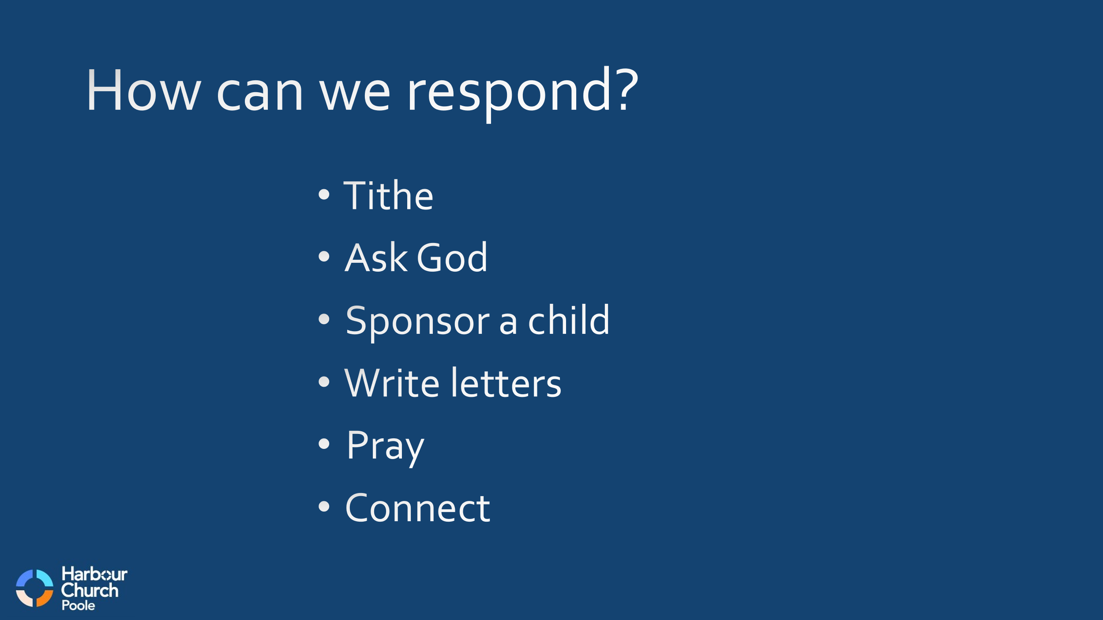
First, don’t neglect your tithe to the church. Give the first 10% of your income, don’t hold back, and live in the blessing of God’s abundance of grace.
But on top of that, ask God what else he wants you to give, and to whom. Don’t just say to yourself, ‘I’m giving a tithe to the church, that’s enough.’ Because God wants to bless you bountifully, as you give bountifully. So ask God, and follow his leading. Not reluctantly or under compulsion, as Paul says. But cheerfully.
And if you’re already supporting other mission work, or sponsoring a child, or supporting other organisations – that’s great! Don’t stop any of that, carry on being generous to them.
But if you hear God prompting you to support any of these three mission partners more specifically, here are some ways to do that:
- Sponsor a child in Sri Lanka or Uganda. Penny has some details with her today. And there are details of children on the Child of Hope website.
- Write letters. If you sponsor a child you will receive letters from them, and you can write to them. Or you can write a message of support to any of our mission partners. Gez has suggested that you write a letter in your small group this week. If you do this, we can collect them together and send them on.
- Pray. Giving is not just about money. Prayer support is just as important. Add these mission partners to your regular prayer schedule. Pray for them whenever God prompts you. Pray for our partners by name. If you sponsor a child, pray for them specifically, and their family.
- Connect. All these mission partners have a regular email newsletter. You can sign up, read the emails, use them as reminders and prompts for what to pray for, or for other opportunities to give where there is a specific need.
So, I encourage you to do any or all of these things. Whoever sows bountifully will also reap bountifully – whether in money, or time, or prayer. God loves a cheerful giver, and God is able to make all grace abound to you. And to quote the final sentence of 2 Corinthians 9, thanks be to God for his inexpressible gift!

So please think about your own response right now. Jane, Andy and Penny will be here at the front if you’d like to talk to them. The prayer team will be here on the right, if you’d like personal prayer for anything. Or, if you’d rather stay in your seat, use this time to respond personally to God, and to pray for our mission partners that we’ve been talking about this morning.

