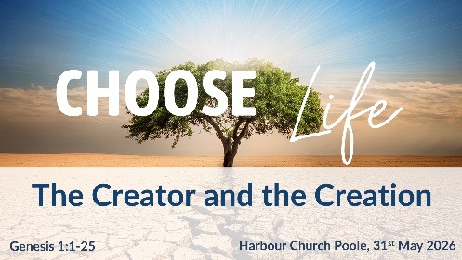
The Creator and the Creation: Genesis 1:1-25
(Harbour Church Poole, 31st May 2026)

Good morning! Who appreciates the beauty of the natural world around us?

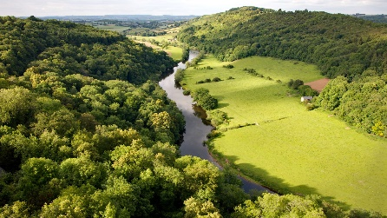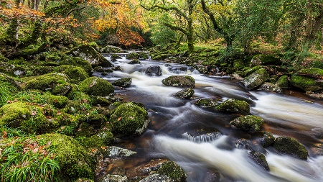
How do you feel when you see a glorious sunset, or the distant views from a high hill, or a clear-running stream bubbling over the rocks, or a golden sandy beach with palm trees? Inspiring, right? Beautiful. Enriches the soul.
Or when you consider the detail of a peacock’s tail, or a butterfly’s wing, or even a common-or-garden daisy? Aren’t they all amazing? Awesome in the intricate detail, in the infinite variety of their colours and designs.
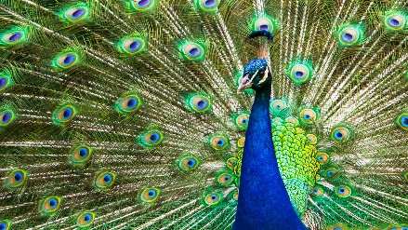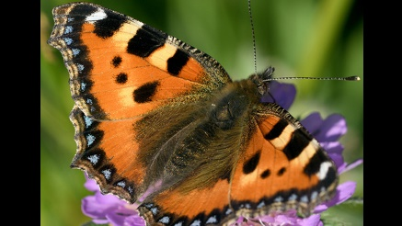
Nature is incredible, isn’t it? Both at the large scale and at the micro scale.
But it isn’t just a ‘natural world’, is it? As Andy pointed out last week, the Bible tells us that the world has been created. And as we look around us, we can see that it’s been created with breath-taking variety and awe-inspiring attention to detail.
Today we’re continuing our series ‘Choose Life’, and this morning we’re looking at the first half of Genesis chapter 1. But we’re not just looking at the creation itself, we want to focus our attention on the Creator – God, the creator of the universe, God our Father.
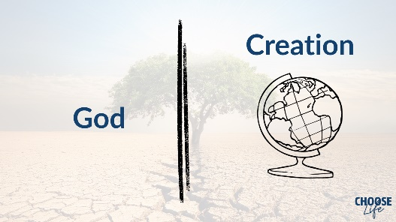
Here’s the diagram Andy used last week – with God the creator, distinct from the world, the creation.
This morning we want to choose to worship the creator of the incredible world we see around us, the world that we are part of.
So, let’s start by reading the passage. XXXX is going to come and read for us, the very first page of the Bible, Genesis 1, verses 1-25.
[read passage]
This is a familiar story, isn’t it? And we’ve stopped at verse 25, because today we’re covering the first 5½ days of creation. We’ll pick up the rest of the 6th day next week, with the creation of man and woman.
Now, when I first drafted this sermon, I wrote quite a long discourse about world views, comparing the evolutionary worldview with the literal creation worldview, comparing science and faith, and so on. But then I decided that’s not the right focus for this morning, so I’m not going to spend any time on that, except to say: if you’d like to discuss evolution vs creation, I’d be very happy to do that – come and see me afterwards. But for this sermon this morning, we’re going to look into the text of this passage, just as it is written.
In the beginning, God created the heavens and the earth. Andy focussed on this statement last week. I’m not going to repeat what he said. Verse 1 is effectively a one-sentence summary of the whole of the rest of the chapter. In the beginning, there was God, and nothing else. And God created the whole of the heavens and the earth.
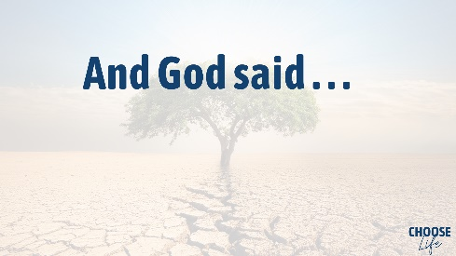
And how does it all start? With a very simple phrase, “And God said,” There it is in verse 3, and again in verse 9, and again in verse 11, verse 14, verse 20 and verse 24. And God said, and God said, and God said... The whole creation is brought about by the word of God.
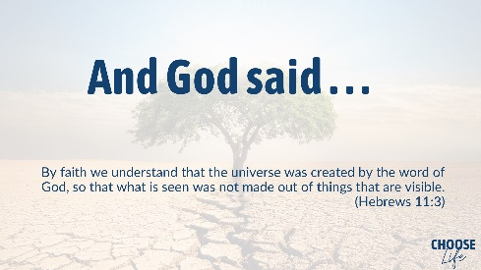
Hebrews 11, that great chapter about faith, starts out with this statement (v3), “By faith we understand that the universe was created by the word of God, so that what is seen was not made out of things that are visible.”
The whole universe was created by the word. ‘And God said…’ Everything that we see was made from nothing, when God spoke it into being.
And John 1 gives us another perspective on creation, emphasising the same thing:
“In the beginning was …” what? – the word. “In the beginning was the word. And the word was with God and the word was God.” John is taking the phrase ‘and God said’ and personifying it by associating the spoken word of God with Jesus the embodied word of God. “He was in the beginning with God. All things were made through him” – that is through Jesus, the word of God – “and without him was not anything made that was made.”
The whole of creation, the whole universe, spoken into existence by the powerful, authoritative word of God. And God said…

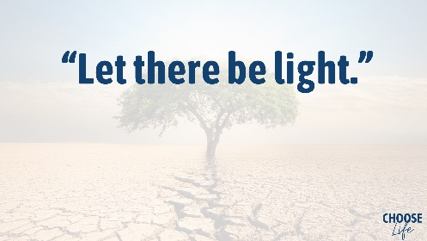
And what did God say first? “Let there be light.” This must be one of the most quoted phrases in the Bible. “Let there be light.” Such a simple statement, yet so profound! “Let there be light. And there was light.” Because God said so. And this was the first act of creation – eliminating darkness, eliminating nothingness, replacing it with light. Because darkness is nothing, is it? It’s just the absence of light.
And in John’s gospel, we get the parallel account: “The light shines in the darkness, and the darkness has not overcome it. The true light, which gives light to everyone, was coming into the world. He was in the world, and the world was made through him.”
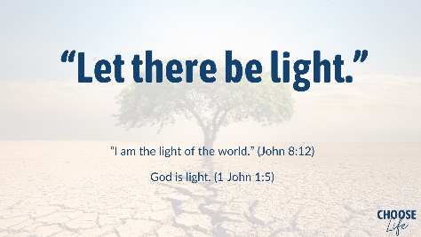
Now John is associating Jesus with the light as well as the word. “I am the light of the world,” Jesus said in John 8:12. And in John’s letter later, he says explicitly, “God is light.” (1 John 1:5) So that’s why light is the first act of creation, because God is light and Jesus is the light of the world. The very light around us right now speaks of the presence of God, the creator. Nothing was visible, and God said, ‘Let there be light.’ And there was light.
Notice that God didn’t say, ‘Let there be a sun.’ That comes later, and we’ll come on to that. We understand, don’t we, that all our daylight comes from the sun, and that moonlight is also reflected from the sun. But that wasn’t how it was in the very beginning. And that’s not how it will be in the end either.
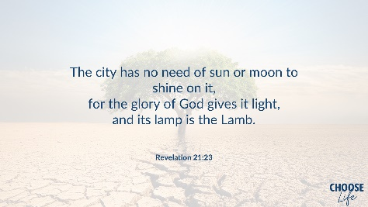
In Revelation 21:23, describing the new Jerusalem, the eternal heavenly city, it says, “the city has no need of sun or moon to shine on it, for the glory of God gives it light, and its lamp is the lamb.” There it is again – God himself gives it light, and Jesus, the lamb, is its lamp. Jesus is the light of the world, forever.
(By the way – it is well worth reading Revelation 21 and 22 alongside Genesis 1-4. There are a lot of parallels – creation in the beginning and restoration at the end, the garden of Eden and the New Jerusalem, the tree of life in both of them, the beginning and the end. So we can see, God is light in the beginning, and God is light at the end. I’ll be drawing more parallels between Genesis and Revelation as we go through this morning.)
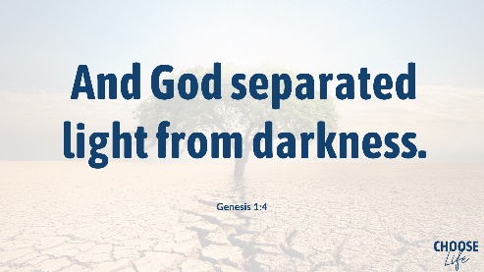
And God separated light from darkness, and called them day and night, and there was evening and morning, the first day. Don’t ask me how this works without the rotation of the earth relative to the sun, because I don’t know, but God’s clearly an awesome creator, so I’m happy to believe he can set up days and nights.
And it says this is the first day. Now some people believe the word ‘day’ in this chapter refers to a much longer period of time - an age, or an era, and you can believe that if you like, that’s OK. But it seems to me the language is quite straightforward, each of the six days it says, ‘and there was evening, and there was morning, the first day, the second day, etc. It sounds like night and day just as we experience them, so I personally have no problem with this whole account taking place in six regular days. After all a God so supremely awesome could just as easily create the universe in six seconds, couldn’t he? But he chose to do it in six days, in so doing he created the concept of the seven-day week, which sets a tone for the rhythm of our lives, doesn’t it?

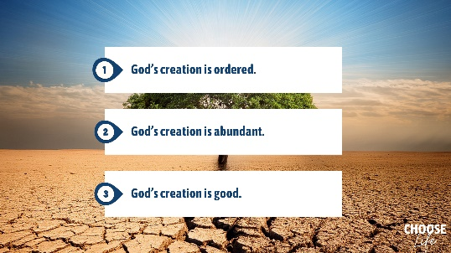
Now let’s look at the rest of the six days of creation. I’m going to take them together, looking at three aspects:
- God’s creation is ordered
- God’s creation is abundant
- God’s creation is good
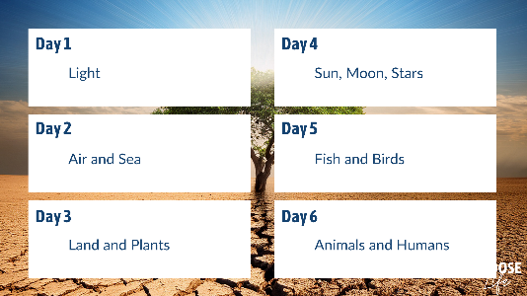
First then, let’s look at how the creation is ordered. Let’s review the six days of creation – there is a definite pattern:
- On day 1, God created light, as we’ve just been talking about.
- On day 2, God created the air and the sea. The language here can be a bit confusing – depending on your translation the air might be called an ‘expanse’ or the ‘sky’ or even ‘heaven’. And the phrase ‘the water above the sky’ might sound odd too, because there isn’t a water supply up there, is there? But in Genesis 7, in the account of Noah, it says that ‘the floodgates of the heavens were opened, and it rained for forty days and forty nights.’ So that’s an awful lot of water that once was originally ‘above the sky’ now on the surface of the earth instead!
- On day 3, God created the land, by gathering the waters of the sea into one place, and presumably raising the height of the land’s surface accordingly. And on that same day he created all kinds of plants and trees growing on the land.
- On day 4, God created the ‘lights in the sky’ – the sun and the moon and the stars. This is not setting out a scientific explanation of how the solar system operates; it’s a description written from a human perspective (although of course there wasn’t a human there at the time) of how God creatively ordered the light into sun and moon and stars.
- On day 5, God created all kinds of birds to fly in the air, and all kinds of fish and sea creatures to swim in the waters.
- On day 6, God created all kinds of animals on the land – wild animals, and domestic livestock and ‘creeping things’. And on that same day he created man and woman too, though I’m not covering that today, because that’s for next time.
But I’ve laid it out like this, so you can see the order. Day 1 is linked to Day 4, Day 2 to Day 5 and Day 3 to Day 6 – do you see? Light on day 1, ordered into sun, moon and stars on day 4. Air and sea on day 2, populated with birds and fish on day 5. Land on day 3, populated with animals and humans on day 6.
It’s an orderly system. And the creation is classified in an orderly way – everything that flies in the air is a kind of bird, everything that lives in the water is a kind of fish, every animal on the land is either a kind of livestock, or a wild animal (or a ‘beast of the earth’ in some translations), or a creepy-crawly thing. In many ways, modern science has confused all this by defining dolphins, for example, and bats as mammals, rather than sea creatures or flying birds. But all classifications are arbitrary, and the classification laid out here is actually quite straightforward and orderly.
And we can also see the order in God’s creation in the movements of the sun and the moon relative to the earth. God said, ‘let them be for signs and for seasons, and for days and for years.’ And from the way that the sun and the moon seem to move, from our perspective, we can measure, can’t we, days, months, seasons, and years, which gives order to our whole system of timekeeping. Although it’s interesting that there’s one important aspect to our calendar system that can’t be measured from the sun and moon – and that is the week. The 7-day week is an extra aspect of God’s order. We’ll cover this again in a future sermon, when we talk about day 7, the sabbath. But I’ll just say here that it’s very clear that in this creation, God established an orderly pattern of six days of work and one day of rest. And this pattern suits the way God has created us, men and women. After the French revolution, Napolean tried to change the calendar. They instituted a 10-day week, specifically to remove Christian influence, but it was a complete failure, and they had to return to the 7-day week after all.
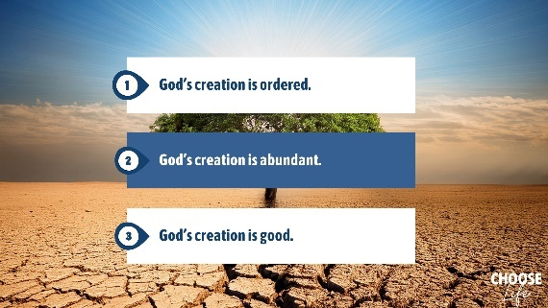
So we can see that God’s creation is ordered. Now let’s look at the second point, God’s creation is abundant.
Look at all the references throughput this passage to growth and multiplication. All the plants yield seeds to reproduce themselves. Trees bear fruit with seeds in them. There are innumerable stars in the heavens. The water teems or swarms with all kinds of fish. Birds fly across the sky. And God blessed them and said, be fruitful and multiply, and fill the seas and increase across the earth.
This is all the language of abundant growth and multiplication. God didn’t just create a few interesting things. He created an abundance of life on earth. He created a fantastic variety of shapes and sizes and colours, and he built into the whole of creation the ability to grow and reproduce and multiply. God’s creation is in no way limited in resources – it’s abundant.
And so it is with God himself – he lavishes us, it says in Ephesians, with abundant grace. He forgives all our iniquity, it says in Psalm 103, he heals all our diseases, he crowns us with love and mercy, he satisfies us with good. And in Revelation 22, just like the Garden of Eden, the heavenly city has the ever-flowing river of life and the tree of life that bears twelve kinds of fruit for every month of the year. That’s abundant life forevermore!
God’s creation is abundant, and he wants us to live in his abundance and enjoy the blessing of his abundance.
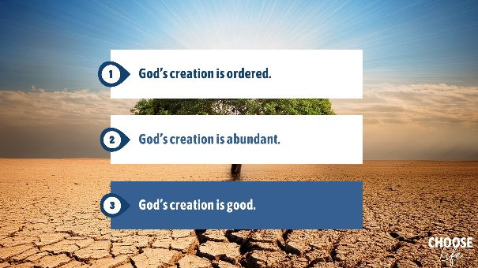
And third, God’s creation is good.
He says so, doesn’t he? Over and over again in this passage. Verse 4, ‘God saw the light was good.’ Verse 10, ‘God saw that it was good.’ Verse 12, verse 18, verse 21, ‘God saw that it was good.’
The beauty and variety of creation, the order of creation, the abundance of creation – God saw that it was all good. And into this good creation he placed Adam and Eve, to enjoy his order and his abundance and his goodness. And of course they succumbed to temptation and tarnished the goodness, as we’ll see over the next few weeks, and I can’t go into all that now. But in the end the new creation will be restored, and once again it will be good. ‘Behold I am making all things new,’ he says in Revelation 21, ‘I will wipe away every tear from their eyes and death shall be no more.’ That’s good, isn’t it?
God is good, and God’s creation is good. He wants us to enjoy it, and he wants us to take care of it. But let us be careful not to idolise it. By all means admire the splendour and beauty and goodness of the world around us, but let’s beware of worshipping created things instead of worshipping the creator himself. Now, I don’t suppose anyone here today actively worships the sun or the moon or a special tree or anything like that. But there’s a more subtle temptation when people talk about ‘Nature’, with a capital N, or ‘Mother Nature’. When someone personifies nature in this way, they tend to forget – or deliberately choose to ignore – that the whole of the natural world was in fact created by God.

To sum up then, the creation reflects and reveals aspects of its creator. Just like a sculpture reflects the person who sculpted it, or a garden reflects the person who tends it. The created world around us is ordered, abundant and good, because God himself is ordered and abundant and good.
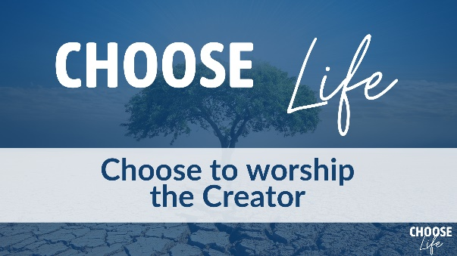
So how should we respond to all this? Let’s respond with worship. As we look at the world around us, as we see how awesome and amazing it is, let us choose to worship God, the creator of it all. He wants us to enjoy his creation. He wants us to enjoy our relationship with him. God wants us to appreciate the order that he has created. He wants us to live in the blessing of his abundance – his provision and his grace. He wants us to live in the good of a close relationship with a loving father.
So let us look at the created world, and let us turn in worship to God, the creator of it all.
God spoke this world into being by his word. And the word became flesh and dwelt among us, Jesus, the son of God. And in the beginning God walked in the garden of Eden with Adam and Eve. And in the end, Jesus will return, and God will once again dwell with his people in a renewed world, and we will see him face-to-face and we will worship him. Come, Lord Jesus!

