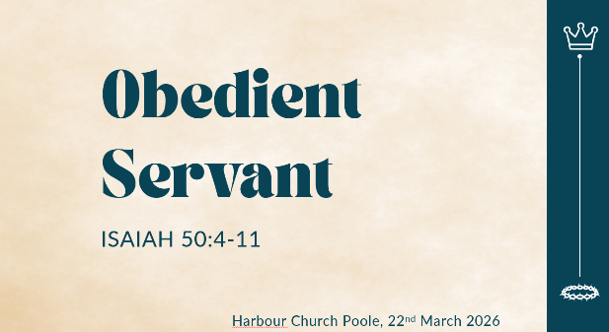
Obedient Servant: Isaiah 50:4-11
(Harbour Church Poole, 22nd March 2026)

Good morning! Today we’re going to talk about Obedience.
I’m going to start with a lot of rhetorical questions to get us thinking.
Who thinks that being obedient is an important life-skill in our world today? Do we value obedience? Do we look for obedience in other people? Do we pursue obedience ourselves?
Let’s start with an easy question. Who thinks it’s important to teach young children to be obedient?
Yes? Most people would agree. It’s important to teach obedience to children when they’re small. Toddlers need to learn to listen and obey Mummy and Daddy, don’t they? They won’t be safe unless do what they’re told, and learn to listen to ‘Yes’ and ‘No’.
And what about dogs? A responsible dog-owner takes time with a puppy to train them, to teach them obedience. And we all prefer an obedient dog to one that’s out of control, don’t we?
But what about adults? Is it important for us to be obedient? And who should we be obedient to? Do we want to live our life being told what to do? Or do we want to make our own decisions for ourselves?
We’re adults, right? We’re not answerable to our parents anymore. Mostly we don’t want to be answerable to anyone, right? At work, we might be obedient to our boss’s direct instructions, but often we’re not particularly happy about it, and we’d rather have the freedom to do things our own way.
And we’re obedient to the law of the land, aren’t we? More-or-less, most of the time! Think about traffic laws. Who is always obedient to the speed limit? Who slows down when there’s a speed camera ahead? So what’s the motivation? Do we slow down because we remember that it’s important to be obedient? Or is it just because we don’t want the consequences of being caught?
If obedience is only about avoiding a conviction or a fine or a formal warning at work – is that really obedience? Do we really value obedience?
So what happened between when we were toddlers and when we grew up? Is obedience important only for very young children? Should teenagers be obedient too? And should we, as adults, value obedience more highly than we do?
There’s a lot of questions!
Now, let’s read the passage for today, which comes from Isaiah 50. And the reason why I’ve started with all these questions is because in most Bibles this passage has the title, ‘The Servant’s Obedience’ or ‘The Obedient Servant’.
So we’ll read from Isaiah Chapter 50, verses 4-11.

Now, let’s be honest, who finds a chapter like this easy to read and understand? It’s not so straightforward, is it? Because this is prophecy. It’s written mostly in the present tense, but it’s describing things that were in the future when God first spoke them to Isaiah. And furthermore it’s written in poetry form, not in straightforward prose. So just think about it - this is a prophetic poem written about 3000 years ago in ancient Hebrew. By the time it’s been translated into English and we read it today, we can be excused for finding it a bit challenging! But the great thing about the Bible is, it’s God’s written word, and God can make it alive for anybody in any generation, through his Holy Spirit.
So to dive into this a bit this morning, this whole part of Isaiah has always been understood (by both Jews and Christians) to be an extended prophecy about the Messiah. And Jesus was, and is, that Messiah, that saviour. So in one respect this prophecy by Isaiah applies to Jesus, his life, and death and resurrection. But since the word of God is living and active, we can also allow the Holy Spirit to apply it to our own lives today.
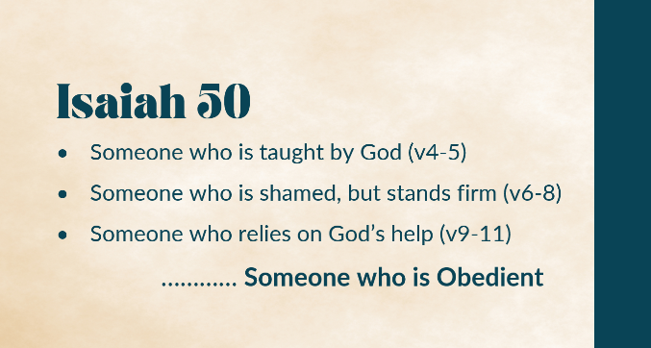
And that’s what we’ll do this morning. We’ll look at the passage in reference to Jesus, and then in reference to ourselves, as we seek to be followers of Jesus.
And the passage has three parts. It describes:
- Someone who is taught by God (v4-5)
- Someone who is shamed, but stands firm (v6-8)
- Someone who relies on God’s help (v9-11)
In other words… Someone who is obedient!

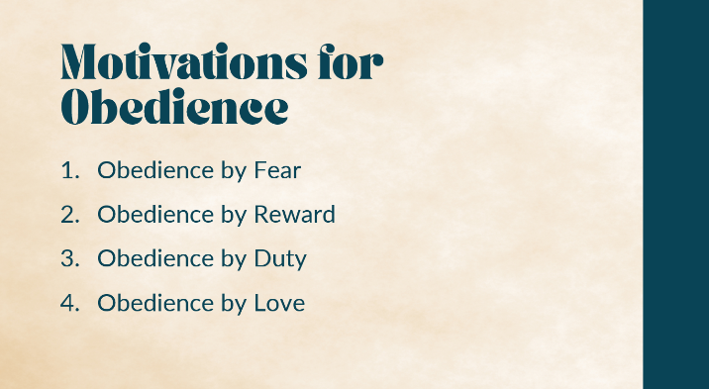
Now, to help us think about obedience, as we look at this passage, at Jesus and at ourselves, here are four different forms of obedience, based on the motivation. We can think about:
- Obedience by Fear: fear of the punishment you’ll get if you don’t obey, like my example of a slowing down for a speed camera.
- Obedience by Reward: we do what we’re told at work, because we get paid for it.
- Obedience by Duty: like a soldier following orders from a strong sense of loyalty or patriotism.
- Obedience by Love: This is what this passage is about, a joyful, selfless, willing obedience stemming from a deep, loving relationship.
And this last one it what we see in Jesus. Throughout his life on earth he was obedient to his Father God, not out of fear, or reward or duty, but out of love.
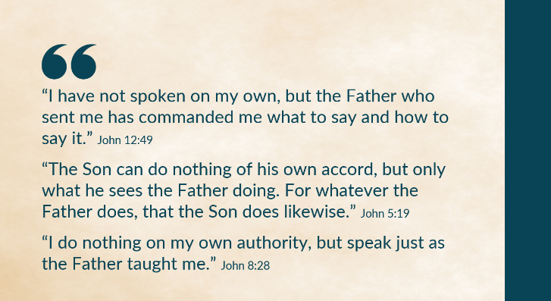
Look at some of the things Jesus said himself:
- John 12:49 “I have not spoken on my own, but the Father who sent me has commanded me what to say and how to say it.”
- John 5:19 “the Son can do nothing of his own accord, but only what he sees the Father doing. For whatever the Father does, that the Son does likewise.”
- John 8:28 “I do nothing on my own authority, but speak just as the Father taught me.”
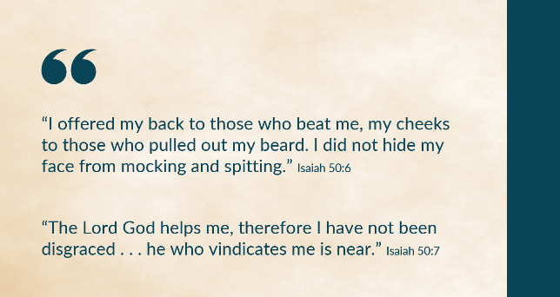
Everything Jesus did and said on earth was in absolute obedience to his Father. He was always listening to his Father, and he always did and said what God taught him. And Isaiah says here in chapter 50, “He wakens me morning by morning, wakens my ear to listen like one being taught.” That’s obedience!
And then Isaiah describes his resilience even in humiliation. “I offered my back to those who beat me, my cheeks to those who pulled out my beard. I did not hide my face from mocking and spitting.” Isn’t this just like what Jesus had to put up with when he was arrested and appeared before the Jewish leaders and before the Roman governor? He was mocked, he was spat upon, he was flogged. And yet he remained silent in the face of this abuse. 1 Peter 2:23 says, “When they hurled their insults at him, he did not retaliate; when he suffered, he made no threats. Instead, he entrusted himself to him who judges justly.” That’s obedience!
And then Jesus endured the most shameful death imaginable, when he was crucified on the cross. Naked and humiliated, nailed up to die in slow, painful agony. This was shame from man’s point of view. But from God’s point of view, completely the opposite. In Isaiah’s words here, “The Lord God helps me, therefore I have not been disgraced . . . he who vindicates me is near.” The night before the crucifixion, Jesus knew all this was coming the next day, and it was almost too much to bear. He was sweating blood as he prayed in earnest, and yet he said, “Not my will, but yours be done.” That’s obedience!
And Jesus had to rely on God’s help. He offered himself as a sacrifice. And he was unable to save himself. As it says in Phil 2:8, “he humbled himself by becoming obedient to the point of death, even death on a cross.” But thanks be to God, that was not the end! “Christ was raised from the dead by the glory of the Father,” it says in Romans 6:4. And Philippians 2 continues, “Therefore God has highly exalted him.” And so we can come to him today and receive our own salvation. But Jesus, having taken on the limitations of being a man on earth, had to rely on God’s help. He chose to face death as a human being, trusting in God to raise him back to life afterwards. That’s obedience!
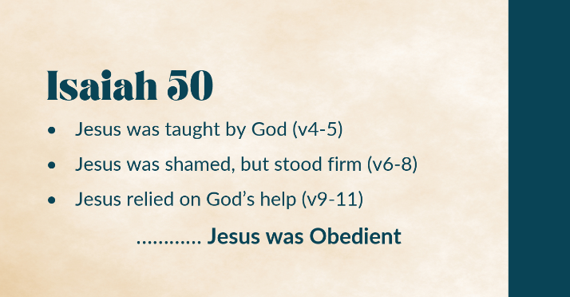
So, we can see how Isaiah’s prophecy applies to Jesus. He was the obedient servant, he was taught by God, he was shamed but stood firm, he relied on God’s help while he was in human form on earth. Jesus modelled true, perfect obedience throughout his human life, out of love for God his Father.
And thinking back to some of my opening questions, it is clear, isn’t it, that obedience was important to Jesus. He wasn’t just motivated by fear, reward or duty. He highly valued being obedient to his Father God. In fact, for Jesus, obedience was literally a matter of life or death!

So, let’s think about us now, as followers of Jesus in Poole in 2026. Do we want to live like Jesus? Do we want to be obedient servants, like Jesus? Do we value obedience as much as Jesus did?
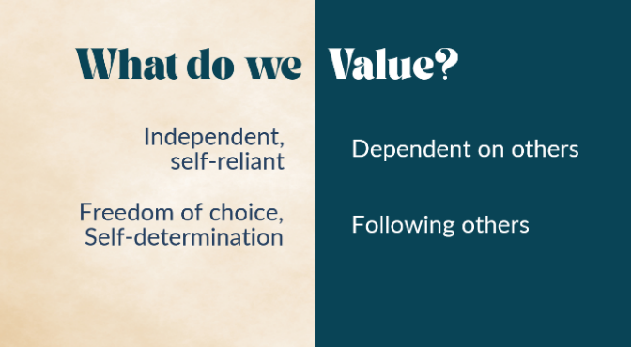
I think there’s a challenge here. Are we prepared to take a counter-cultural view? Do we share the prevailing values of our culture? Should we challenge that? What do we really value?
Have a look at these:
- Is it better to be independent and self-reliant… or dependent on someone else?
- Is it better to have freedom of choice and self-determination… or to follow someone else’s lead?
Which of these do you value most? Which do we encourage in our children as they grow up? Self-reliance, Self-determination – they’re characteristics to be admired and encouraged, aren’t they? Isn’t it good for your wellbeing and success to discover your own core values and live authentically, rather than letting someone else decide for you?
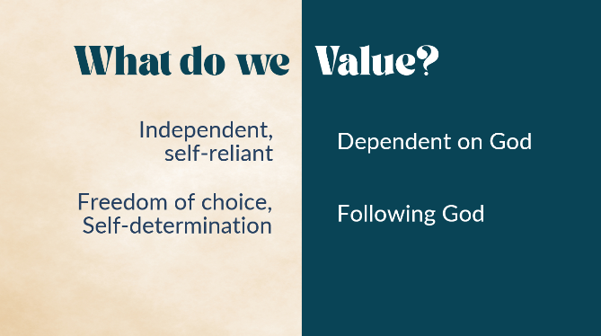
Now look at it this way:
- Is it better to be independent and self-reliant… or dependent on God?
- Is it better to have freedom of choice and self-determination… or to follow God’s teaching?
Does that change the way you look at it?
Which of these did Jesus value most? He was always taught and led by God, wasn’t he? He was always reliant on God’s help. He was obedient.
So if this side (on the right) is obedience, what is the on the other side? What’s the opposite of obedience? Isaiah has it in v5 of our passage, “I was not rebellious.”
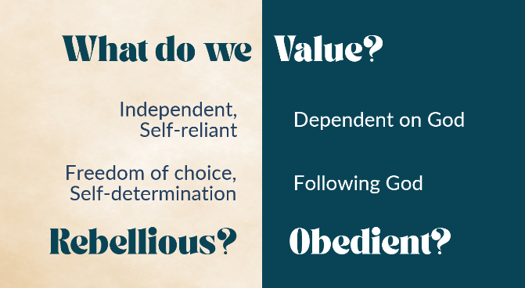
Could it be rebellious to be independent and self-reliant and to choose for myself? Does our culture value rebelliousness more than obedience? Are we encouraging our children to give up on obedience as they grow up, and embrace rebelliousness instead?
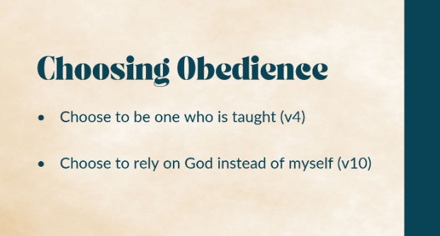
It’s a challenging thought, isn’t it? If Jesus so highly valued being obedient, shouldn’t we do so too? Can we detach ourselves from the cultural norm and learn to practice obedience? Can we choose to follow Jesus, to be obedient, out of love?
I’m going to suggest two possible ways to respond to this passage this morning, two ways to start practicing obedience. We can:
- Choose to be one who is taught (v4)
- Choose to rely on God instead of myself (v10)
I was quite pleased when Andy allocated this passage to me to preach on today, because I’d read it myself just a few weeks ago. I often read the Bible using the Lectio Divina approach, expecting the Holy Spirit to highlight to me a specific verse or phrase, and then praying and reflecting on that. And when I read Isaiah 50, God really highlighted to me one phrase in particular from verse 4, and that was ‘one who is taught’. (In some translations it is ‘those who are taught’, or ‘instructed’.)
And I felt God saying to me, will you be one who is taught? Or do you think you can always figure things out for yourself? Will you awaken your ear, he said to me, will you listen to my teaching? Will you be obedient?
And I was so taken up with this thought for several days, that I wrote a poem – a prayer-poem. So this is my personal response to this passage, based on Isaiah 50 v4

One Who is Taught
Oh, that I could always wake
Hearing you speak
Oh, that I could tune my ear
Your voice to seek
Oh, that I could tame my tongue
To talk with thought
Oh, that I could always be
One who is taught
I pray that I may follow you
And live your way
I pray that you would give to me
Words for today
I pray for faith to listen and
Speak as I ought
I pray for grace to learn to be
One who is taught
(You can read it on my substack, if you like, where I publish my poetry.)

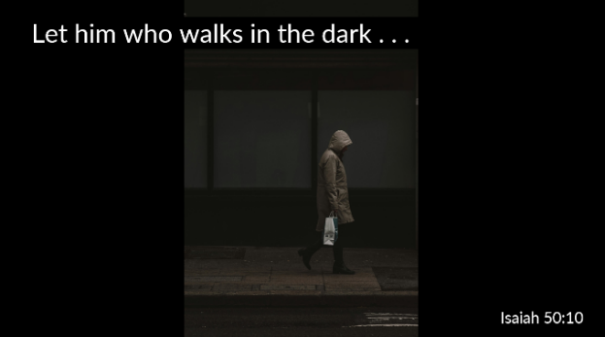
The second verse in this passage that speaks more directly to us is v10. “Let him who walks in the dark and has no light trust in the name of the Lord and rely on his God.” Now this sounds rather obvious, doesn’t it, and I’m sure we’d all agree with it. If I’m in the dark without a light, I should rely on God.
But, actually, what would we typically do? We’d look for a light, wouldn’t we? We’d want to strike a match, find a lightswitch, use the screen on our phone! Our natural response is to try to fix the situation ourselves. And often, we don’t really think of turning to God until we’ve run out of our own resources.
And that’s exactly what Isaiah describes in his next sentence. “All you who light fires and provide yourselves with torches, go walk by the light of your fire and by the torches you have kindled.” Good solution, right? I’m in the dark, I’ll light a torch and then I can find my way. But what does Isaiah say that God says about this? “This is what you shall receive from my hand: you will lie down in torment.”
Now, I have to say, that sounds pretty extreme, doesn’t it? Lie in torment, just because you chose to use your own torch instead of relying on God! But that’s how Isaiah closes this passage, and that’s why reading a prophetic poem is harder work than simple prose!
But the basic message is clear enough. The obedient way is to rely on God. The rebellious way is to find your own solution. Yet how many of us only turn to God after we’ve tried our own way. Or else we think we know the best way, and then we ask God to come alongside us and make our way work – rather than asking him what his way is. I need to admit, that’s what I often do.

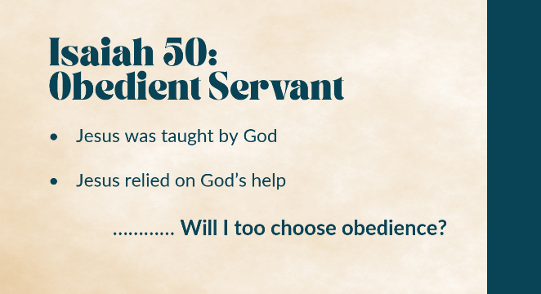
So, to wrap up. 3000 years ago, Isaiah wrote a prophecy about the Obedient Servant. 1000 years later Jesus Christ showed us how to live as an Obedient Servant, motivated by love. And now, another 2000 years later, we live in a world that doesn’t really value obedience (except in toddlers and dogs!).
So the challenge is, will we follow Jesus and seek to live in obedience? Will we choose to be taught by God? Will we choose to rely on God? Or do we think we know better?

