
Gideon Trusts God: Judges 7
(Harbour Church Poole, 16th August 2026)

Good morning! We’re continuing the story of Gideon this morning, picking up from where Fred left off last week. So today, we’re looking at Judges chapter 7. In the NIV, the title of this chapter is ‘Gideon Defeats the Midianites’. But I’d like to suggest a more accurate title would be ‘Gideon Trusts God, and God Defeats the Midianites’. Because, really, it’s a story of God taking away nearly all that Gideon had, in order to demonstrate how to trust God, instead of trusting in ourselves.
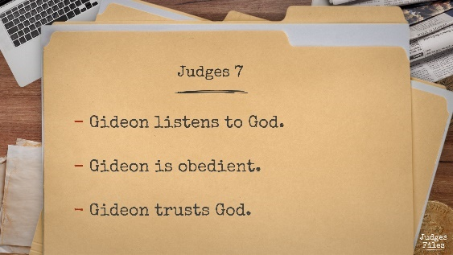
We’re going to look at this story with three headings:
- Gideon listens to God
- Gideon is obedient
- Gideon trusts God
We’ll see this is a repeated pattern in this story. God speaks, and Gideon listens. Gideon is obedient, even when he’s not confident, and even when God’s directions seem counter-intuitive. And Gideon trusts God for the outcome, rather than trusting in his own strengths.
And as we go through it, we’ll think about this for ourselves too – am I listening to God? Am I ready to be obedient? Will I trust God instead of managing by myself?

So we’re going to go through Judges chapter 7. I’m not going to read the whole chapter, because it would take five minutes out of my allotted time, but I’ll go through the story, and if you’ve got a Bible with you, I’d encourage you to follow along. First, in case you weren’t here last week, we need to set the context for this chapter. The Midianites have been oppressing the Israelites for the past seven years. They’ve been raiding them, taking away their livestock and destroying their crops. And now God has called Gideon to lead Israel and save them from the Midianites. And Gideon has received a confirmation from God in the sign of the fleece.
So as we start chapter 7, Gideon has called up an army from the people of Israel. He’s got 32,000 men with him, and they’re camped up on Mount Gilead. But down in the valley is the Midianite camp. And they look (it says in verse 12) like ‘locusts in abundance, and camels without number, just like the abundant sand on the seashore.’ In other words, there are lot of them! Actually, from chapter 8, we learn that there were about 135,000.
So Gideon’s got 32,000 men, and the Midian army is more than four times larger. That’s quite challenging, isn’t it? God’s promised a victory for Gideon, but he’s outnumbered 4-to-1. So he needs to trust God, right? And God can win a victory for them, even though the odds are against them, right?

That’s probably what Gideon’s thinking. Just like Fred was describing last week, Gideon is not very confident, but God’s confirmed his word with the sign of the fleece, so he’s willing to go for it.
But what happens next? Verse 2, ‘The Lord said to Gideon…’
Who takes the initiative here? Who leads the conversation? It’s God, isn’t it? Now Gideon was probably praying to God, preparing for the upcoming battle. The text doesn’t spell it out, but we can imagine Gideon’s prayer, can’t we? ‘Please God, this army is much bigger than we are, but please help us to overcome them with your mighty power.’ That’s how we usually pray, isn’t it? ‘Please God, help me with [whatever], because I can’t manage on my own.’ And we come to God with our request in prayer, just like Gideon probably did.
But prayer should be a two-way conversation, shouldn’t it? Whatever Gideon was actually praying to God is not written here in this chapter. The important thing that’s recorded here in the text is that God spoke to Gideon. And Gideon listened to God.
Have you heard that old adage? We’ve got two ears and one mouth for a reason; it’s best to use them in that proportion. Listen more, speak less! Heard that before? But do we apply it to our prayers? When we pray to God, do we listen to him too? Do we expect to hear from him? Or do we just come with a list of requests? Is my prayer life genuinely a two-way conversation with God? Am I willing to let God take the initiative, and speak to me in a way I didn’t expect?
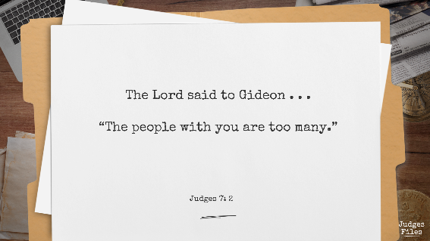
Because we need to be willing to listen, even when God says something we don’t expect. What did God say to Gideon? “The people with you are too many.” Can you imagine Gideon’s thoughts? ‘What? Too many? But we’re heavily outnumbered already!’ But God is gracious, and he explained to Gideon, ‘You’ve got too many men, for me to give you the victory, because they’ll be boastful and think they’ve done it themselves.’
And then God said something even more surprising – ‘whoever is fearful and trembling, let him return home.’ This is not what Gideon expected. But he listened, and he was obedient. He proclaimed this instruction to all the people. And more than two-thirds of them went away, leaving him with just 10,000 men.
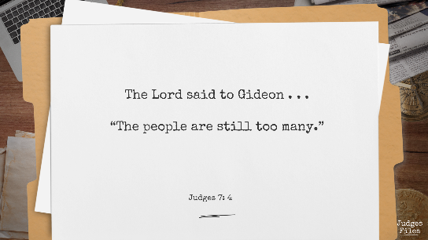
This is very real, isn’t it? How many people who are in an army don’t feel afraid when faced with an actual battle? Think of the people in Ukraine for example, on the front line, defending against Russian attack – most of them believe in the cause they’re fighting for, but how many of them are fearful or trembling? Probably about the same two-thirds, I reckon.
So Gideon’s left with 10,000. That’s now less than 1 against 10. Time to trust God, right? But God’s not finished with the conversation. Look at verse 4, “And the Lord said to Gideon, ‘The people are still too many.’”
‘What? Still too many? But we’re even more outnumbered now!’
And God gives some more directions, and Gideon listens to God, and Gideon obeys God’s directions. And he takes all 10,000 of them down to the water to drink. And he observes them all, and he ends up with 300 men over here who lapped the water, and 9,700 over there who knelt down to drink. And Gideon’s probably thinking, ‘Now what?’ But he’s still listening to God, and God says, ‘With the 300 men who lapped I will save you and give the Midianites into your hand. Let all the others go home.’
Now if you read commentaries about this passage, you’ll find various theories about why the men who lapped the water were somehow ‘better’ than those who knelt down, because they were more prepared, or more alert to danger, and so on. But I don’t think we need a ‘rational’ explanation. I think the point is that God wanted far less people, and he showed Gideon a way of whittling down the numbers without any human judgement about who would be ‘best’. And once again Gideon listened to God, and Gideon was obedient, even though God’s directions didn’t seem to make much sense.
And again the challenge to us is: am I ready to listen to God? Am I willing to be obedient, even if God’s directions don’t seem to make sense to me? Will I trust God? Or do I think I know better?

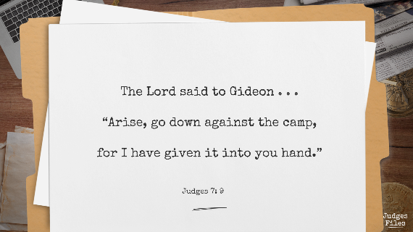
So now Gideon is left with 1% of his original army. 99% have been sent home. 300 people left against 135,000 Midianites. The odds are now 1 against 450.
And now God is ready to act. He says to Gideon, ‘Arise, go down against the camp, for I have given it into your hand.’ Simple, right? You and your band of 300, go get ‘em. I have given you the victory. Just like that.
But God is gracious too. He knows Gideon will be a bit flummoxed by all this. So he says, ‘If you’re afraid…’ ‘You bet I am,’ says Gideon. ‘That’s ok,’ says God, ‘creep down, just you and your servant, and hear what they say.’
And again Gideon listens to God, and Gideon is obedient. And he overhears a conversation between two of the Midianites, where one of them is describing a dream to the other. And Gideon hears the interpretation of the dream, from the mouth of a Midian soldier, “God has given Midian and all the camp into Gideon’s hand.”
Isn’t that a gracious way for God to encourage Gideon? Because Gideon listened to God, because he was obedient, he heard this encouragement from a most unlikely source. But it was just what he needed. He chose to trust God, and he came straight back to his own camp and roused his 300 men. And he repeats to them what God has said to him, ‘Arise, for the Lord has given the host of Midian into your hand.’
And God is always abounding in grace towards us too. As we seek to listen to God more, as we seek to be obedient, he is gracious with us. Just like Gideon needed extra encouragement, God is willing and able to give us encouragement too. If he says something unexpected to us, if he leads us in a surprising way, the message of the story of Gideon is that it’s ok to look for confirmation. God wants us to have an open conversation with him – just like Gideon – as we learn to listen and to trust him more.


I can give you a personal example of this, from about 25 years ago. This was my office, Discovery Court in Wallisdown. I was looking for a new challenge at work, and I’d applied to a couple of internal vacancies, and I found myself with two offers. One was with a team in Poole; I already knew the manager and quite a few of the team, and the job felt more or less within my competence. The other was a complete unknown – I knew almost nothing about the area of the work, I’d only met the manager once at my interview, and I knew no-one in the team except for one person, who’d recommended me to apply. And the manager was in Coventry, and I would be the only person in Poole in his team. This second one felt very much like the high-risk option.
And I remember praying and asking God about it. I was on a train, or even a plane I think, on the way to some work event, and I took a piece of paper and started writing down what I felt God was saying to me. And I heard him quite definitely prompt me to take the second option, even though it seemed risky and outside my comfort zone. So the next day I rang up the manager in Coventry and accepted his offer.
But God knew the future that I didn’t know. About a year after that, the whole company was in financial dire straits, the share price collapsed, and there was large-scale cut-backs. Out of the blue we were all called into a big meeting, and they announced that the entire Poole office would be closed, and all 550 of us made redundant. Except . . . that same afternoon, my new manager phoned me, and said, ‘I don’t want to lose you. How would you like to change your contract to a work-from-home contract?’ And so, I wasn’t laid off. I was spared the year-long redundancy process.
I felt this was the grace of God in abundance for me. In actual fact, I’d been wondering whether it would be possible to change to home-based working, and here it was being offered to me! And if I hadn’t listened to God that day, if I’d taken the rational, ‘safe’ choice, I’d have been laid off and looking for another job. So I’m glad I chose to ask God and listen to him. And I’m very glad that God worked by his grace to bring a good outcome through the circumstances.

But now, let’s get back to Gideon’s story. It’s time for him to act in obedience to God’s direction. He divides his people into three groups of 100. And he gives each one of them a trumpet, and a flaming torch that can be hidden in an earthenware pot. And he positions his three groups in three places, surrounding the Midianite camp. And the text doesn’t say so, but we can be sure that all these details were directed to him by God, as he continued to listen to God.

So it’s the middle of the night, and they’re all in the dark, and most of the Midianites are asleep. Then Gideon blows his trumpet and smashes his pot and waves his burning torch. And so do the 100 men with him, and as soon as they see it, so do the other two groups of 100. So there are 300 men blowing their trumpets, and waving their torches, and shouting, ‘A sword for Yahweh and for Gideon.’
Just think about this for a minute. Did they have swords? I guess so. But where were their swords? Each of them had a trumpet in his right hand and a torch in his left hand, so they didn’t have a hand spare for a sword. Their swords were still in the scabbards, I assume, hanging on their belts.
Because Gideon trusted God. He listened to God and he was obedient, and God won the victory on their behalf. God didn’t need their swords. He turned the Midianite army on one another in confusion, and they were routed by Gideon and his 300 men, who just stood and blew trumpets and shouted.
God won the victory, just as he’d promised. Gideon listened to God, he was obedient, and he trusted God for the outcome. And no one even thought of suggesting that they’d won the battle in their own strength, because God had taken all that away in order to demonstrate that the victory was entirely God’s doing.
And God can bring victory in our lives too – whatever situation we’re facing. If you’re feeling under attack today, if you’re facing difficulties in health, in finance, in relationships, turn to God in prayer. Seek his help, but don’t presume to tell him how his should fix the problem. Let God speak to you. Listen to him obediently. Trust him for the outcome.

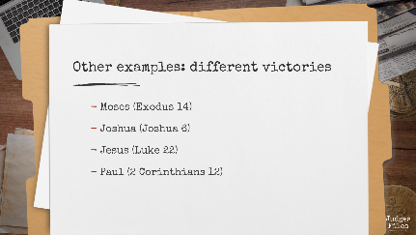
Because God works differently in all situations. There are lots of other examples in the Bible, similar to Gideon’s.
In Exodus 14, the people came to the Red Sea, and they could see the whole Egyptian army charging after them. But Moses listened to God, and he was obedient, and on that occasion, he said to the people, ‘Stand firm, the Lord will fight for you, you have only to be silent.’ And the Egyptian army was drowned in the sea.
Or think of Joshua, when he came to Jericho. Joshua listened to God, and he was obedient, but God’s directions were quite different, weren’t they? ‘March round the city every day for six days, and then march round seven times on the seventh day.’ And then the walls fell.
Different situations, quite different directions from God. But Moses, Joshua and Gideon all listened to God and did what he said and trusted him. God wants to act for all of us, but none of us should assume that God wants to act in the same way as he has done for someone else in the past. That’s why it’s so important to listen in prayer, not just to ask.
And God will give the victory. But sometimes the victory isn’t the way we might have liked it to be. Jesus had to grapple with that, didn’t he? His last night on earth, he prayed to God, ‘Let this cup pass from me, but not my will but yours.’ And Jesus listened to God as he prayed that night, and he was obedient. And God won the victory, through his death and resurrection, because he trusted his Father.
And Paul prayed to God when he was troubled with his ‘thorn in the side’ (whatever that was). And Paul listened to God, and God said to him, ‘My grace is sufficient for you.’ So Paul trusted God, and in his case the victory was that he was able to continue living with his troubling health condition. But because Paul listened, and because he trusted God, he was able to show all of us through his letters how amazing the grace of God really is toward us.
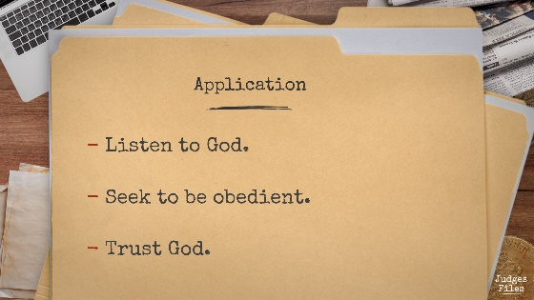
The common thread in all these examples is that they all listened to God, they were all obedient, they all trusted God. So my encouragement to you this morning is this – bring your situation to God. Just like Gideon looking down at the Midianites spread like locusts across the valley. Engage in conversation with God in prayer, but don’t just ask for whatever seems to you the ‘right’ solution. Seek to listen to God, and to be obedient. Trust God for the outcome, because we can be sure that God’s victory will be far better than anything we could think or imagine.

Can we pray together? Father God, just like Gideon, we bring our problems before you. Whatever the situation you’re facing now, bring it before God. (Pause) Lord, we want to listen to you, we want to be obedient. (Pause) Please help us to trust you and encourage us, just like you encouraged Gideon when he was unsure. Lord, we want to trust you for the victory, however you want to do that. Thank you for your abundant grace toward us.

We’re going to close with another couple of songs together now, and as we do so, if you’d like to pray with someone else, the prayer ministry team will be available here on the right-hand side.

