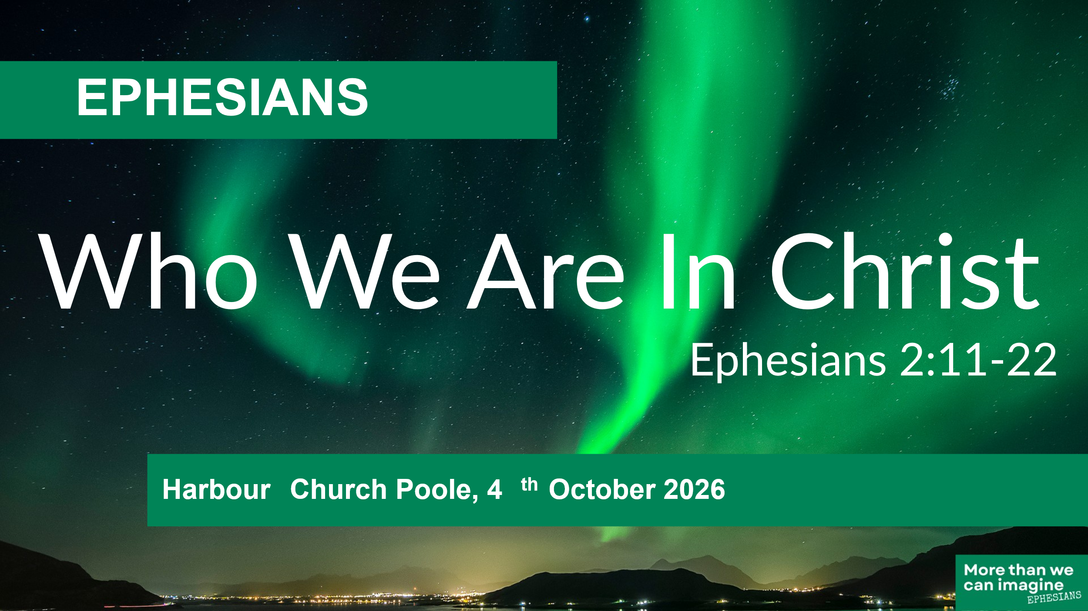
Who we are in Christ: Ephesians 2:11-22
(Harbour Church Poole, 4th October 2026)

Good morning! What’s the most basic question that people ever ask themselves?
Who am I? Who am I? Everybody asks that, maybe consciously or unconsciously, but we all want to know. Who am I? And closely linked to that are two other questions: Why am I here? And, Where am I going?
These are the basic needs of our souls – Identity, Purpose and Destiny.
- Who am I? What’s my identity?
- Why am I here? What’s my purpose?
- Where am I going? What’s my destiny?
And in the Bible, God answers these questions over and over again. Only in God we can truly find our identity, our purpose and our destiny.
Today we’re looking at the next section of Paul’s letter to the Ephesians, and we’ve come to the second half of chapter 2, verses 11-22.
June is going to read it for us. Do follow along in your own bible, or it’ll be on the screen behind us too.

Now, on one level, the main focus of this passage is Paul showing that the gentiles are just as much a part of God’s church as the Jews are. This letter was written to a mixed Jewish and Gentile community in Ephesus, and in this passage, Paul is addressing both groups. He wants the Jews to understand that the Gentiles are included in God’s church, and he wants the Gentiles to see that they’ve been included with the Jews in God’s people. That’s why you see the word ‘both’ several times, and the phrase ‘one new man instead of two’. Paul is encouraging unity in the church between the Gentiles and the Jews. Both Jews and Gentiles, he’s saying, are saints together, united through Jesus Christ in the family of God.
So I could spend my time here this morning focusing on this unity, how the Jews were, and still are, God’s chosen people and how Gentile Christians have been added in, to be included along with the Jews. But this could become quite academic, and in any case, I think we’re almost all Gentiles here this morning, aren’t we? So, I’m not going to focus on the Jew vs Gentile aspect of this passage, and instead I’m going to look at what Paul is saying about our identity.
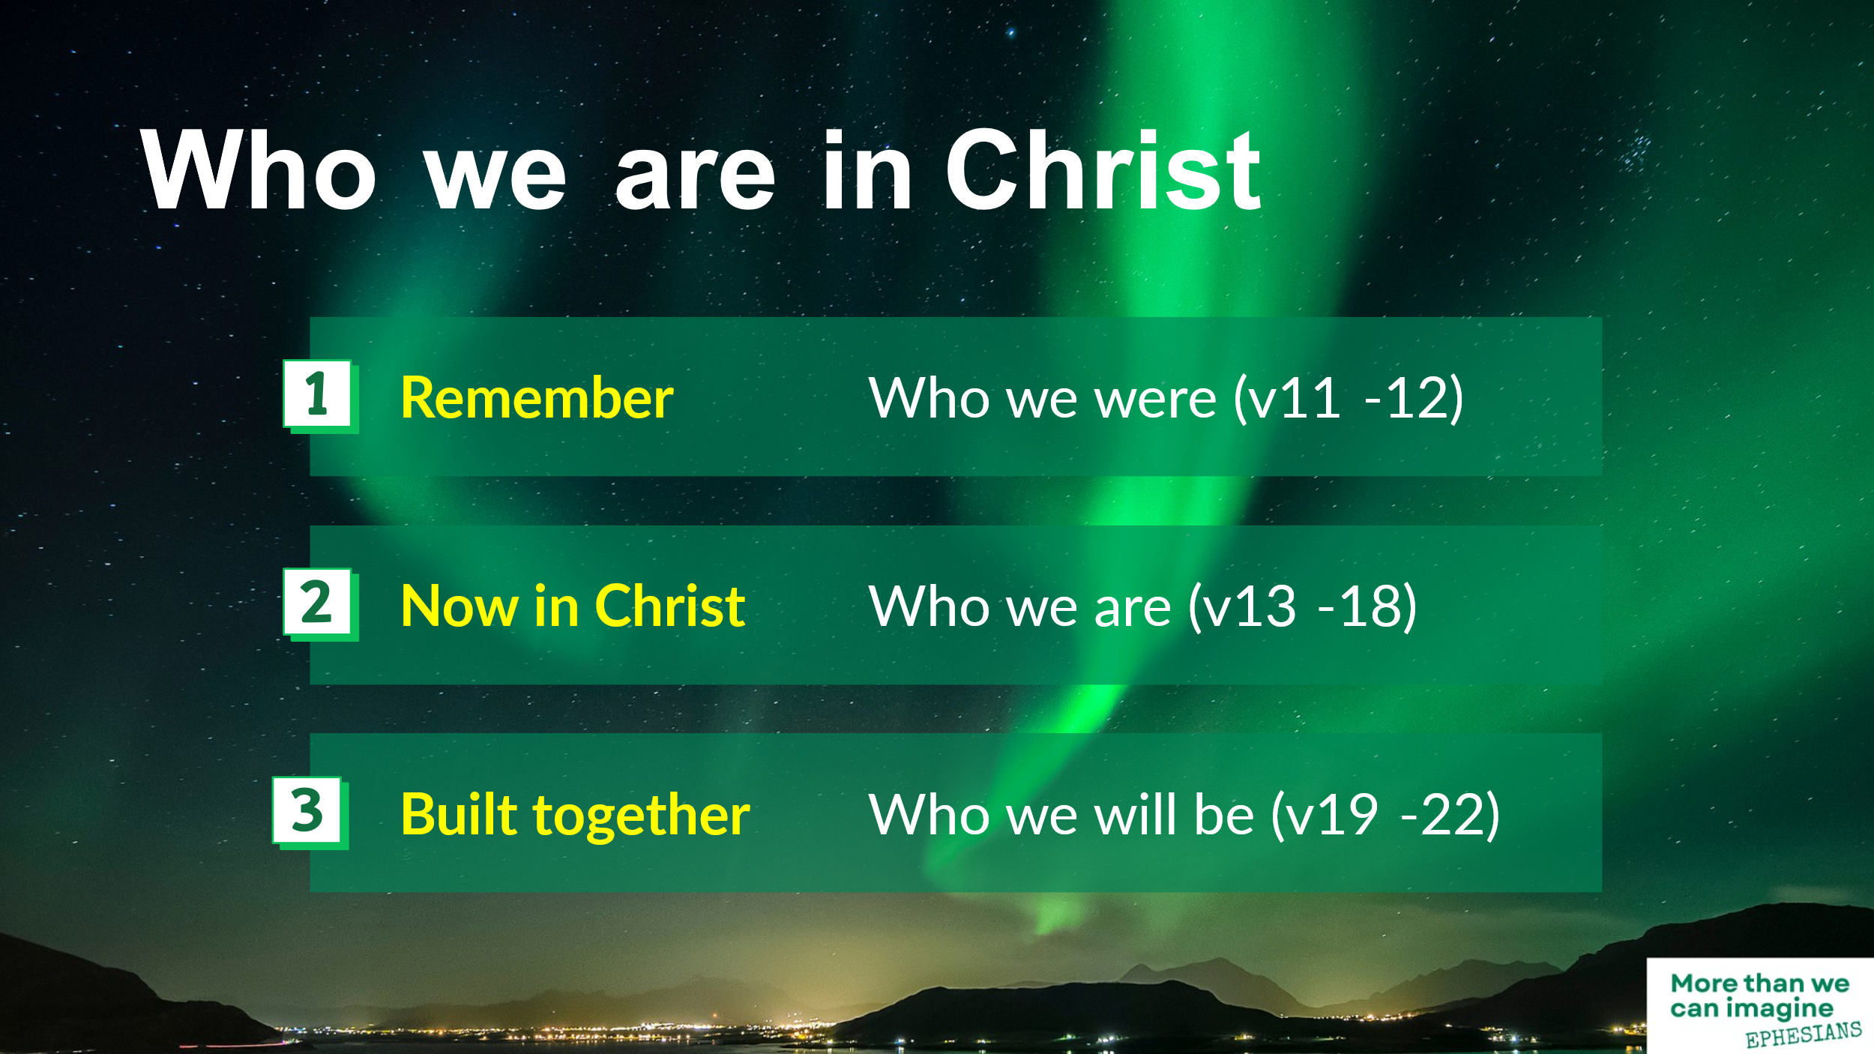
Because this passage addresses who we all are in Christ. It comes back to that basic question: Who am I? Not just am I Jew or Gentile, but who am I in Christ?
We’ll look at the passage in three sections:
- “Remember”: who we were. (v11-12)
- “Now in Christ”: who we are. (v13-18)
- “Built together”: who we will be. (v19-22)
And as we look, we’ll see how Paul addresses identity – past, present and future. Who was I? Who am I now? Who will I be?
So let’s start with looking back. What’s the first word in this passage? ‘Remember’! Both in v11 and v12, Paul says, ‘Remember’. But remember what? Remember who you were, before you came to Jesus Christ. And there’s quite a list here, isn’t there?
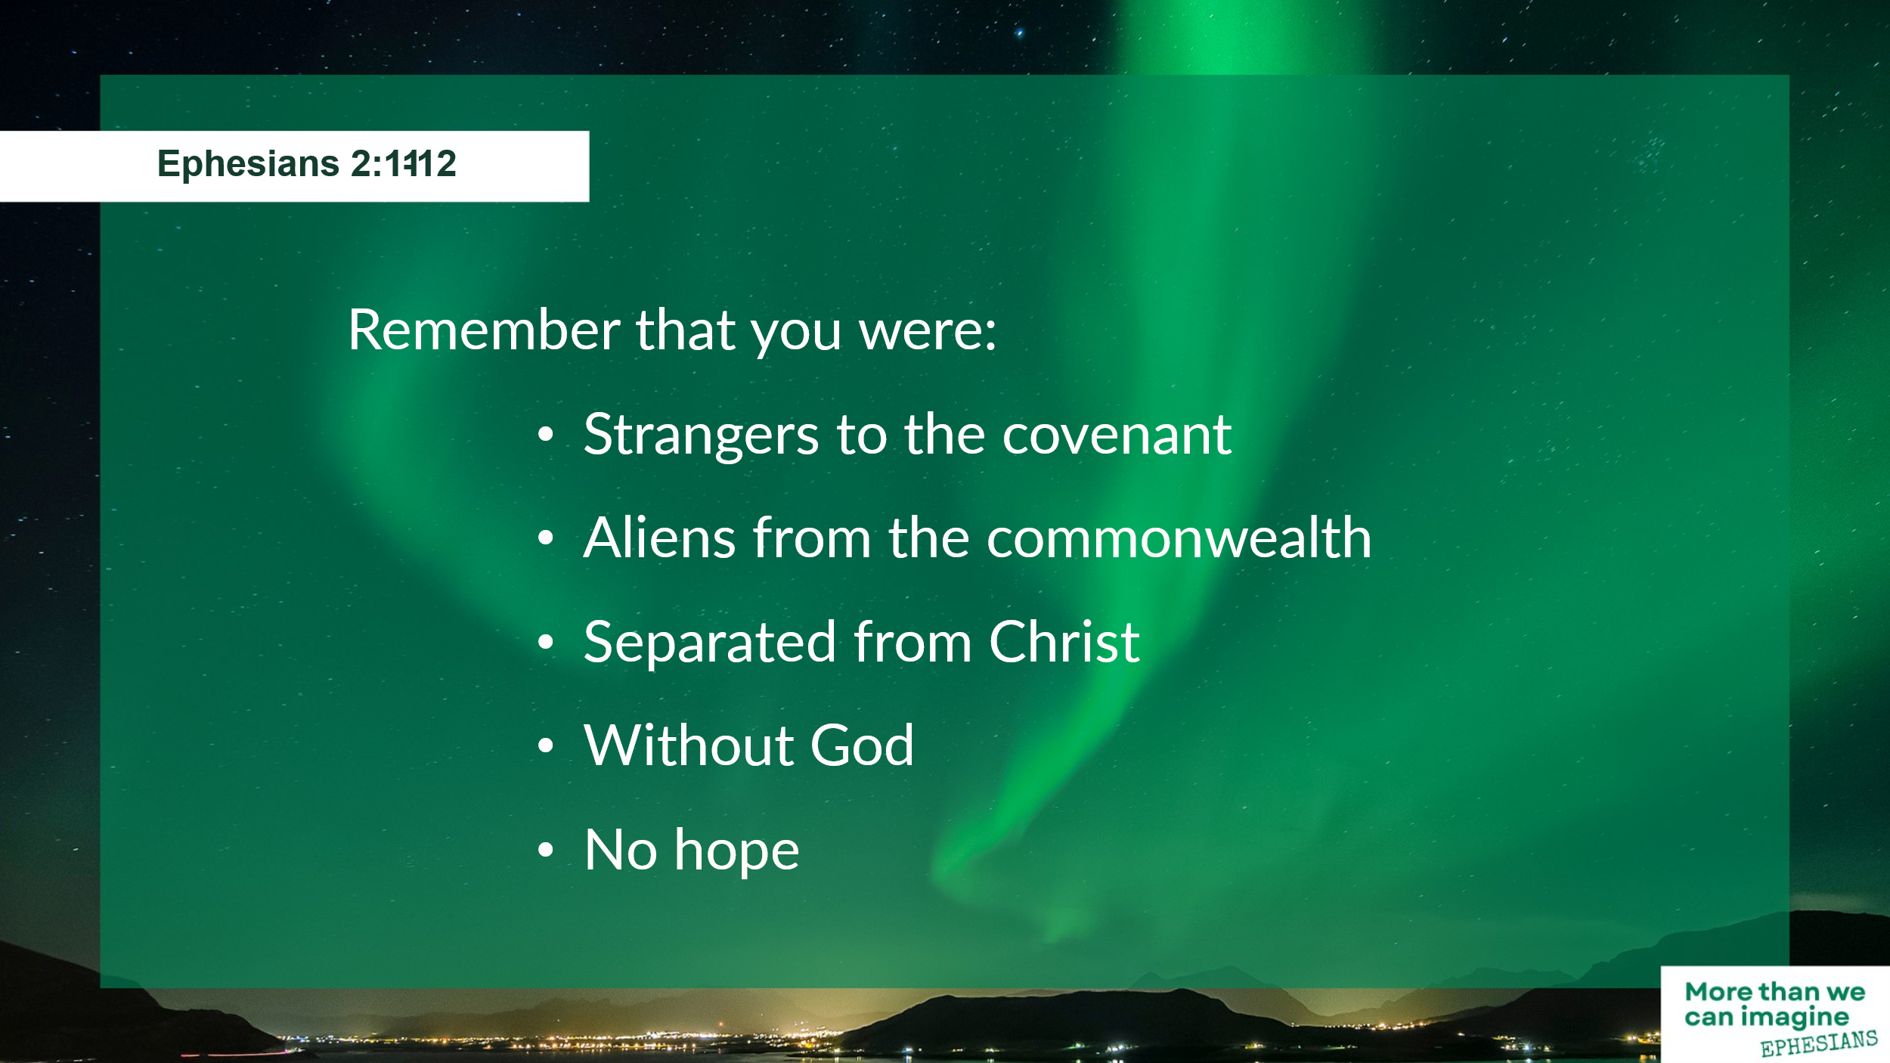
Remember that you were:
- Strangers to the covenant
- Aliens from the commonwealth
- Separated from Christ
- Without God
- No hope
Remember who you were. Apart from God there is no hope. Before we accepted Christ we weren’t part of the family of God. We were excluded from all the covenant promises of the Old Testament. We were like strangers or aliens. Cut off. Unable to reach God.
Remember who you were. And isn’t this reality for so many people all around us today? Separated from Christ, people are miserable, hopeless, alone, lost. ‘Who am I?’ they ask, and they answer themselves, ‘I don’t know.’ Or perhaps they don’t want to ask, or they don’t want to consider the answer, and instead they turn to drink, drugs, parties, work, pleasure-seeking – anything to try to fill the gap, to try to avoid the painful thoughts having no clear identity, no sense of purpose, no sure destiny.
And that’s how we all were once, Paul says. And maybe even right now, this morning, some of you here in this meeting feel like a stranger or an alien, unsure who you are, whether you belong. Maybe some of you are searching for identity, or maybe you’re hiding behind a mask, pretending to be someone that deep down you don’t really know. Or maybe you’re simply longing to be included and accepted. Because right now, this morning, there is hope, for every one of us. Father God is ready to welcome you with open arms, and to restore to you that identity you’re missing.
When I was in the Navigators (in my student days a year or two ago now!), we used an illustration called ‘The Bridge to Life’ to illustrate this.
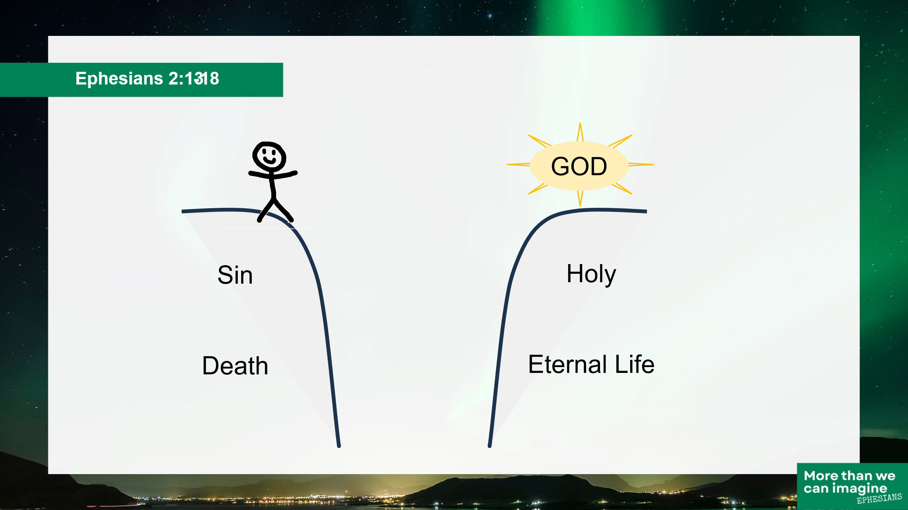
Here’s you or me, over here. And here’s God over here. And we know God offers this free gift of eternal life. But we are over here, and we know that we’re sinners. We haven’t done everything right. We’ve done bad things. We’ve all sinned, it says in Romans 3, and we all fall short of the glory of God. And the wages of sin is death, it says in Romans 6. And so we feel hopeless. We feel separated from God. There’s this great gulf between us, and we can’t straddle it. No amount of good works on our part are enough to bridge the gap.
Remember who you were, says Paul at the start of this passage. And then in verse 13 comes the vital point of hope. “But now in Christ Jesus,” he says. “But now in Christ Jesus you who once were far off have been brought near by the blood of Christ.”
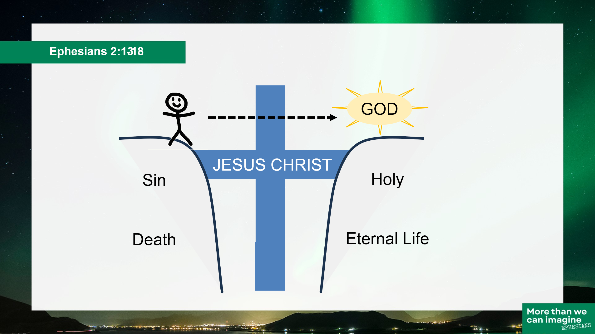

God sent his son Jesus Christ into the world, to be born as a baby, to grow up and live as a man, to die on the cross, to shed his blood to pay the penalty for our sins, once for all, to bridge the gap, to reconcile us to God. “He himself is our peace” it says in v14. “He has reconciled us to God through the cross” (v16).
And if you’re a disciple of Jesus here today, if you’ve accepted his offer of forgiveness, and you’re seeking to live in obedience to him, you can live in the good of that new identity. Who am I now? I am a child of the living God, I am born again, I have received the Holy Spirit, and I have the sure and certain hope of eternal life with God my saviour. Jesus Christ has bridged the gap, and brought me into an intimate relationship with God. “Through Christ,” Paul says in v18, “we have access in one Spirit to the Father.” (repeat)
And if you haven’t yet accepted Jesus Christ as your saviour, or if you’re not sure where you stand here this morning, the offer is open to you right now. It’s a free gift of grace from God to every one of us. You just need to repent, to turn away, from the sins of your old life, and accept the new, eternal life that God offers. Choose to believe in Jesus Christ as your saviour, and seek to obey him as a disciple, that’s someone who is learning from a teacher. Everyone in this room is imperfect, we all have faults and weaknesses, but because of Christ’s sacrifice, we can draw near to God and seek to follow him in our daily lives. That offer is open to you now this morning. “Through Christ we all have access in one Spirit to the Father.”

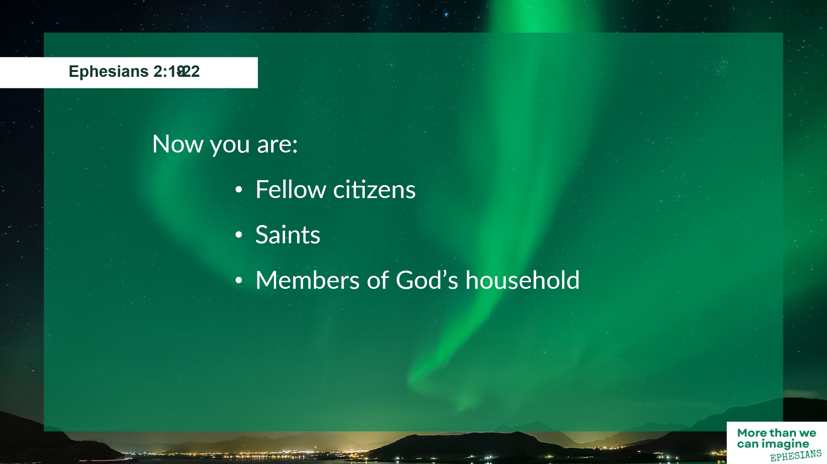
So, we can remember our past identity, who we were, and we can appreciate our present identity, who we are now in Christ. Now let’s move on to the last few verses, 19 to 22, where Paul starts to talk about our future identity, who we will become.
Look at this list, compared to the one we had before. “You are no longer strangers and aliens” he says in v19, but you are
- Fellow citizens
- Saints
- Members of God’s household
Doesn’t that feel a better place to be? Included instead of separated. Members of God’s family, members of the community. Fellow citizens – with the Jews, yes, and with each other, and the whole Christian church worldwide. And we are all counted as saints – which means we are all counted as holy before God, because our identity is in Christ, not just in ourselves.
And Paul uses the metaphor of building here. Jesus Christ is the cornerstone, he says. The apostles and prophets form the foundation. And we all are being built together on that foundation. And what is the result of this? It’s in verse 22, “a dwelling place for God.”
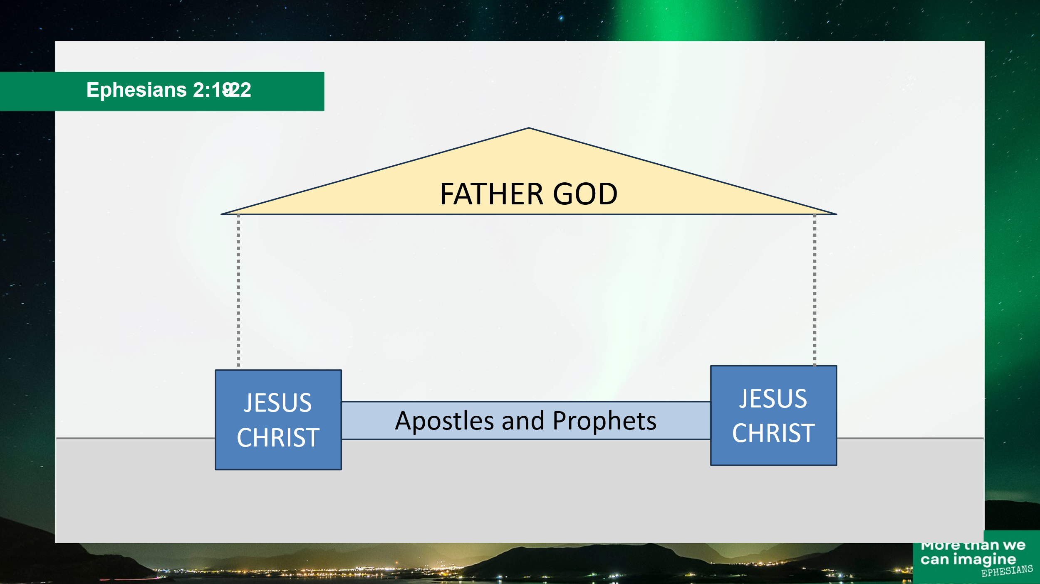
He’s got in mind a temple, a grand building fit for God, just like the one described in the Old Testament, that Solomon built.
Now, for a large stone building, the most important thing is the cornerstone. Actually, a rectangular building needs four cornerstones – they are large blocks, much larger than the rest of the stones used in the building. And they are set in place to form the four corners. They define the alignment of the building, and they are set well into the ground, because they need to be rock-solid to keep the walls in place as the building is built. Without good cornerstones, there’s a real risk that the weight of the walls will push the corner out of line and weaken the whole structure.
So Paul says, Jesus Christ is the cornerstone. Christ anchors the whole building. And then, between the cornerstones, each wall needs a good foundation, a footing. And here, Paul says, the foundation is the teaching of the apostles and the prophets – in other words the Bible, New Testament and Old, which together form a sound base on which to build.
And how are the walls built? What are they built with? With living stones! People, like you and me! Paul doesn’t actually use the phrase ‘living stones’ here in Ephesians, he just says ‘we’re being built together’ but there’s a parallel verse in 1 Peter 2:4-5: “As you come to Christ, . . . you yourselves like living stones are being built up into a spiritual house.”
Both Paul and Peter have the same idea in mind. We all together are being built into this dwelling place for God. This temple is made up of the whole world-wide church, built from living stones – not perfect square-cut blocks, but imperfect people, like you and me, learning to follow Jesus together, with all our rough edges, and awkward shapes and sizes.
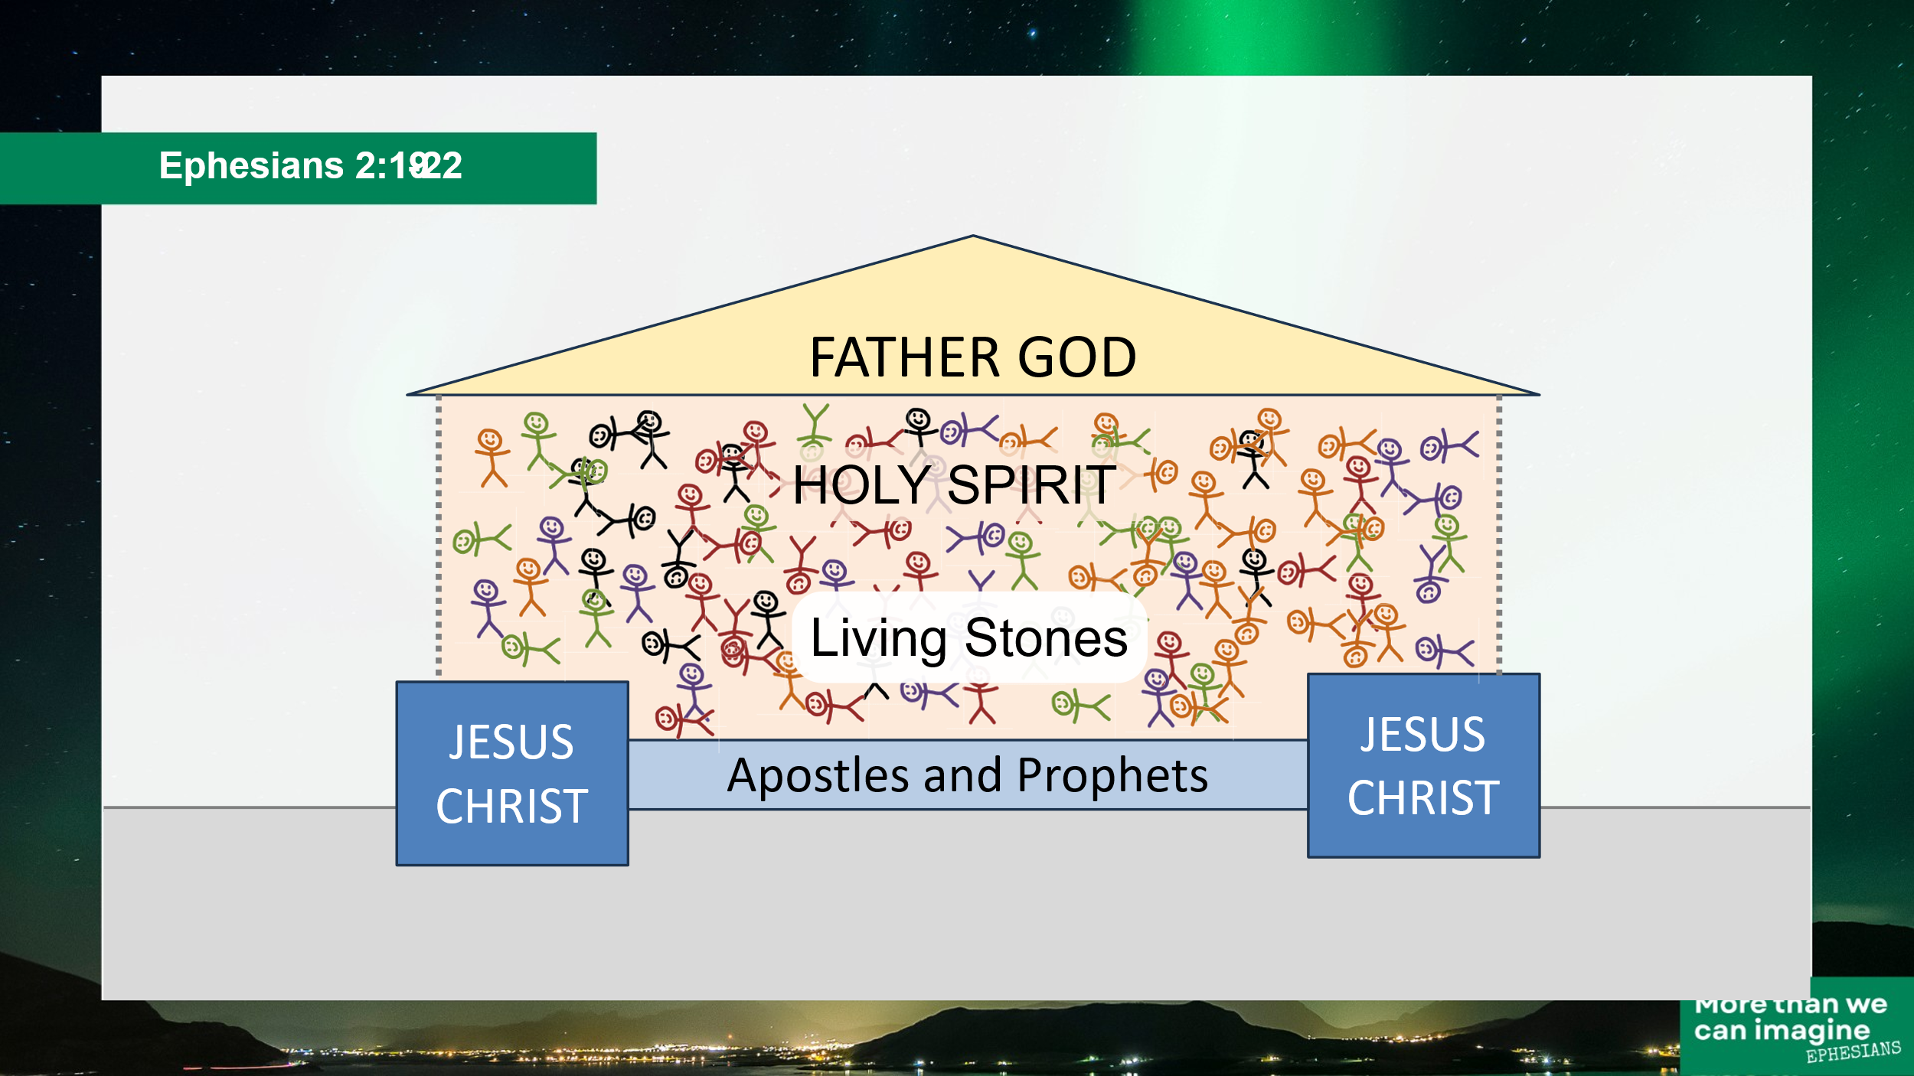
And all those awkward living stones don’t necessarily fit together easily, which is why the cornerstone, Jesus, is so vital, and why it’s important to have the apostles and the prophets as our foundation. But there’s one other aspect at play too. Do you see the very last phrase in verse 22? We are being built together by the Spirit, or in the Spirit. The work of the Holy Spirit is crucial in forming us into a dwelling place for God. We’re not perfect, are we? We have rough edges, we rub each up the wrong way, don’t we? Who could build a dwelling place for God out of imperfect people like us?
Amazingly, God doesn’t look at me and say, ‘you’re not good enough to be part of my dwelling place.’ He doesn’t say, ‘I can only build with perfect people.’ No, in his amazing grace he welcomes rough-edged people – just like you and me, and builds us together by the Holy Spirit into his dwelling place, into his family.

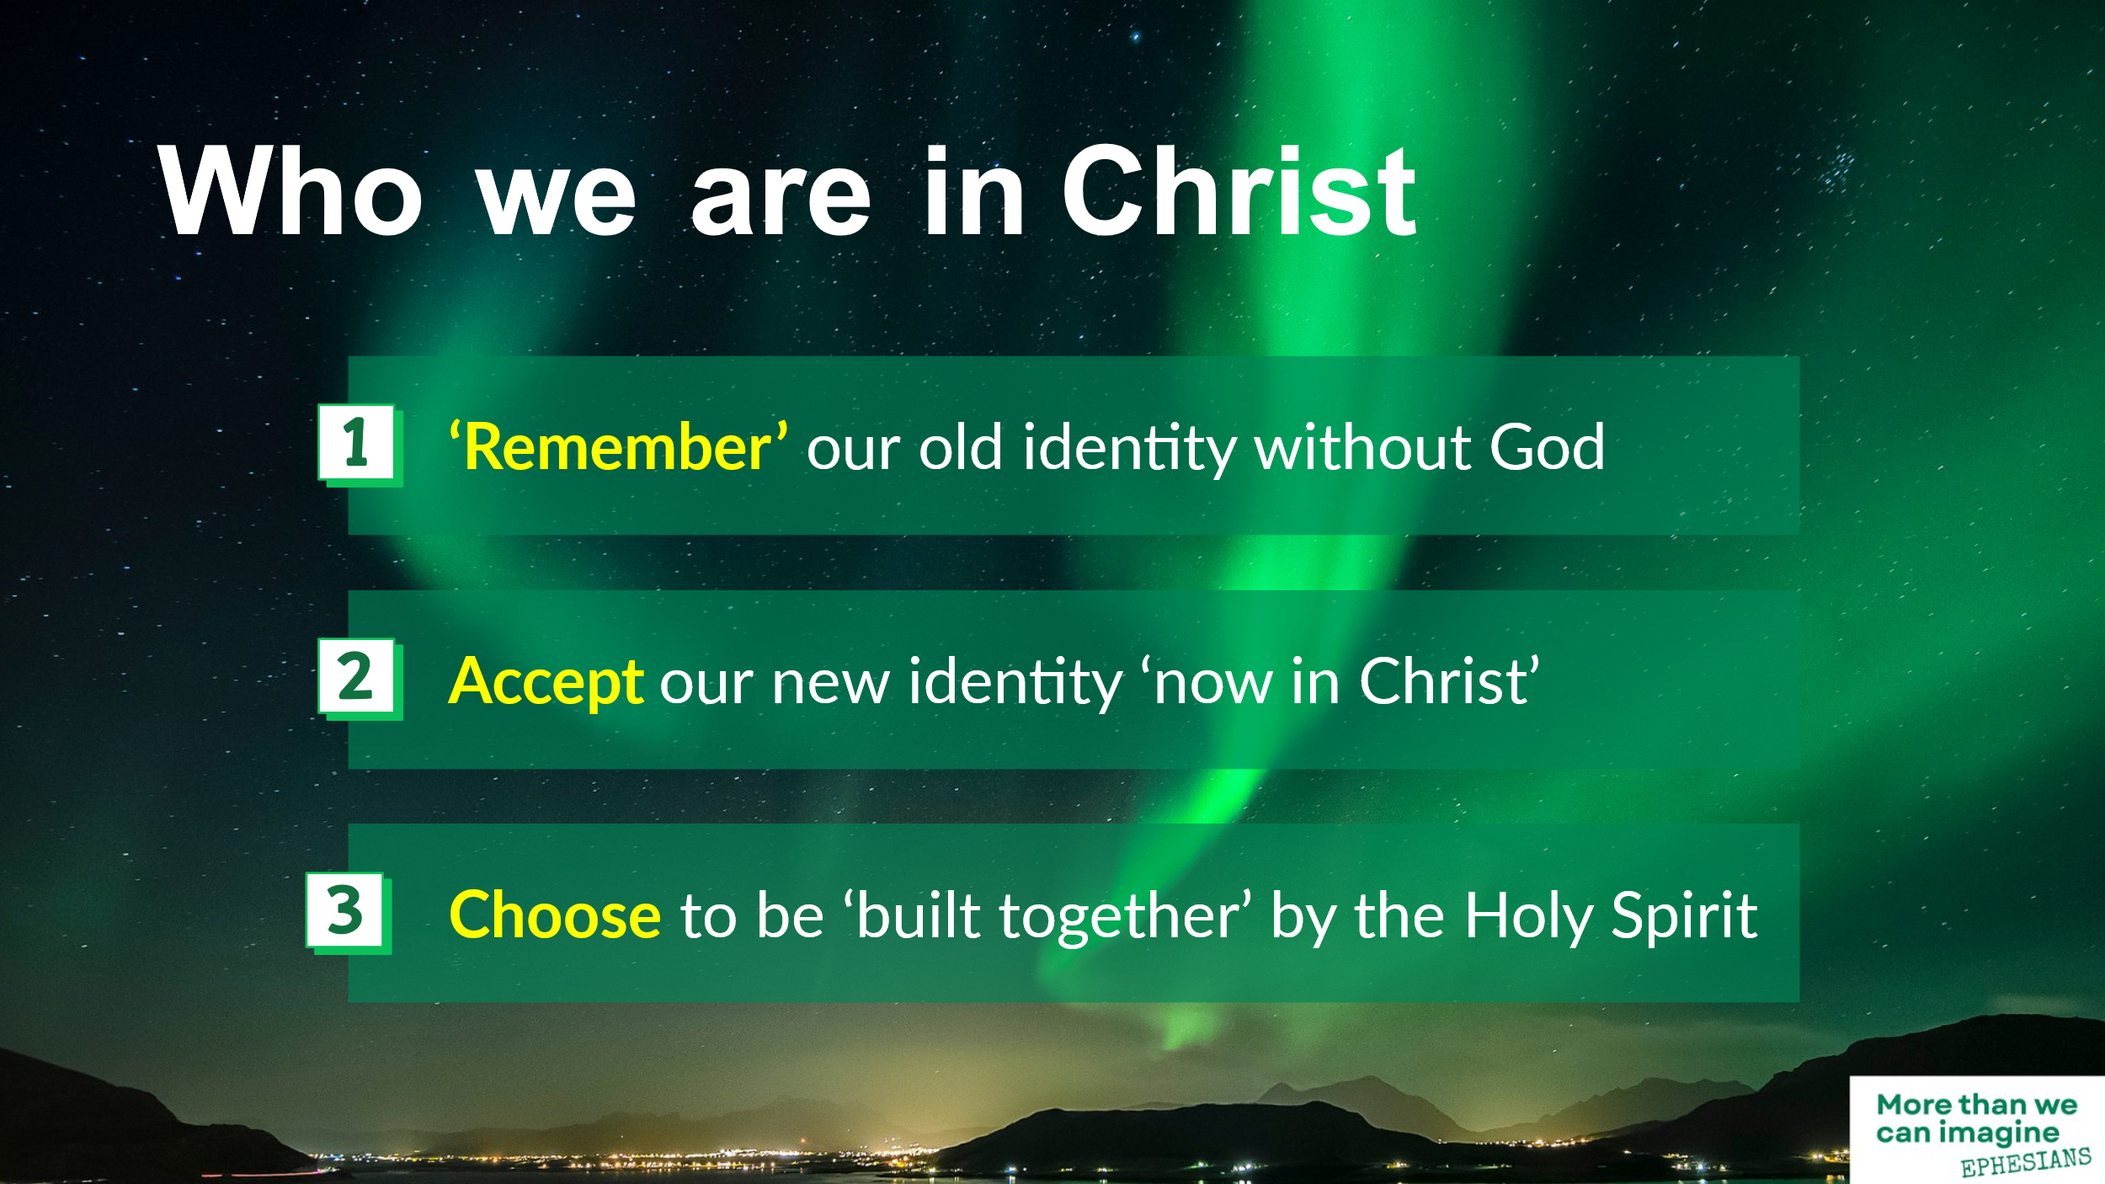
So, how should we respond to all this? God offers every one of us a new identity, a new purpose, a new destiny in Christ. The question is… will we accept that offer?
This is God’s offer for you and me this morning. Through Jesus Christ we all have access in one Spirit to the Father. This is how we can be built together into a dwelling place for God by the Spirit.
- “Remember” our old identity without God
- Accept our new identity “now in Christ”
- Choose to be “built together” by the Holy Spirit
And this offer is for every one of us this morning. We’re all at different places in our relationship with God, and we can all choose to trust him more, to follow him more wholeheartedly.
My great friend and mentor David King had a prophetic statement that he used to repeat frequently. Some of you will remember it. He used to say, “You are one of the most important and influential people alive on planet earth today.” And at first hearing it sounds trite, but it’s actually a profound statement about who we are. You are one of the most important and influential people alive on planet earth today. You are! Not because of anything you’ve done, but because of the high value God places on you, because of what God has done for us in his amazing grace.
So that’s what I want to leave you with this morning. We each have a God-given identity, a God-given purpose, a God-given destiny. Remember who you once were, without God, without hope. Accept the reconciliation that God offers through the blood of Jesus Christ on the cross. Choose to be led by the Holy Spirit today and tomorrow so that we can be built together as the place where God dwells.
In a minute I’m going to lead us in a short pause to reflect, to talk to God and to receive from him. And wherever you are in relation to God this morning, we have a prayer ministry team who will be happy to pray with you after this if you like.
If you’re feeling separated from God this morning, hopeless, his offer of peace and hope is here for you right now. You can repent from your old way of life, receive the reconciliation that is in Jesus Christ, and the new identity that God offers. Today can be the first day of a new life and a new purpose.
Or if you’re feeling unsure about your identity here this morning, turn to God and let him reassure you who you really are in Christ, how valuable you are, how important you are in God’s eyes.
Or if you’re here this morning, confident about your identity in Christ, take this time to ask the Holy Spirit to lead you, to build you together into an ever-deeper relationship with God who loves you.
Let’s pray . . .

